 **CITY OF MUTARE**

**BUDGET PERFORMANCE REVIEW: 15 OCTOBER 2021**

**2021 YEAR BUDGET PERFORMANCE REPORT**

INTRODUCTION

The year 2021 remains one in which COVID took a huge toll on national operations and our council was equally affected. Several lockdown restrictions were imposed by government in a bid to control infections. Operations were reduced to low levels and at the peak we operated at 10% of capacity. These restrictions meant reciprocal reduction of service delivery since critical human resources were not available to discharge some of the duties. Some of our staff members were infected by the deadly virus and the effects of this pandemic are too broad to quantify for now. This took a huge knock on our revenues but at the same time we had escapable fixed overheads which we still had to pay irrespective of economic slow down and reduced inflows. In such a pandemic residents became incapacitated to fully pay for their services due to job layoffs but at the same water, sewer and refuse collection services were in higher demand as a direct result of COVID 19. Council found itself in a dilemma in which residents were demanding more and better services which they could not afford but at the same time council had no alternative source of funding to provide the demanded services. We ended up rationalizing our operations to strike a balance and we hope for a better future as COVID statistics slow down.

Whilst the government has relaxed restrictions we remain alert to the effects of the pandemic and we call upon all to remain practicing safety measures as advised by our medical doctors such as social distancing, sanitizing, wearing face masks and getting vaccinated. Although it was such a tough year we managed to stabilize revenue inflows courtesy of several revenue enforcement initiatives that complimented each other leading to a relatively stable council.

REVENUE COLLECTION

A total of $1,230,785,171.58 was billed to June 2021 against a budget of $ 1 896 477 105.77 which is a 64,90% budget performance. New budget income lines could not be realised as initially planned due to slowdown in economic activity in the generality of the economy. Economic slow down has spiral effects on every sector and as a result this impacts on council collections and performance. We collected $ 701 110 735 for the same period against billing of $**1,230,785,171.58** reflecting a collection efficiency of 57%. The daily average collections were $5.4 million per day. This collection includes US$ which were collected courtesy of our **“MAINTAIN UP TO DATE ACCOUNT”** promotion. Residents were enjoying the promotion but the coming in of SI-127 disrupted the momentum that we had gained with this promotion. We suspended the promotion for close to two months from 28 May 2021 to 23 July 2021 and only resumed after clarification with RBZ wherein it was clarified that this SI was targeting those who were abusing the forex allocated from the RBZ auction system. The table below shows monthly USD collections from January to June:

|  |  |
| --- | --- |
| **MONTHLY USD COLLECTION** | |
| **MONTH** | **TOTAL** |
| January | 95,239.16 |
| February | 94,651.57 |
| March | 212,927.33 |
| April | 214,679.34 |
| May | 254,362.67 |
| June | 106,494.94 |
| **TOTAL** | **978,355.01** |

Out of the $978,355.01, $258 824.98 is attributable to land sales.

The promotion continues to be affected by widening parallel market rates which erodes the benefit of the discount and in turn makes our promotion unattractive.

|  |  |  |  |  |
| --- | --- | --- | --- | --- |
| **FIRST HALF REVENUE**  **PERFORMANCE ANALYSIS** |  |  |  |  |
| **REVENUE STREAM** | **BILLING & ACCRUAL JAN- JUNE** | **RECEIPTS JAN - JUNE** | **VARIANCE** | **VARIANCE**  **%** |
| **WATER** | 361,723,454.40 | 131,662,598.00 | 230,060,856.40 | 36.40 |
| **SEWERAGE** | 109,174,806.05 | 58,671,482.00 | 50,503,324.05 | 53.74 |
| **RATES** | 175,240,070.83 | 102,696,461.00 | 72,543,609.83 | 58.60 |
| **SUPPLEMENTARY**  **CHARGES** | 106,885,501.12 | 55,026,256.00 | 51,859,245.12 | 51.48 |
| **RENTS** | 21,730,433.32 | 17,985,723.00 | 3,744,710.32 | 82.77 |
| **REFUSE** | 113,330,410.40 | 55,583,870.00 | 57,746,540.40 | 49.05 |
| **FIRE** | 34,765,403.89 | 14,086,753.00 | 20,678,650.89 | 40.52 |
| **EDUCATION LEVY** | 17,331,839.57 | 3,229,980.00 | 14,101,859.57 | 18.64 |
| **ST LIGHTING** | 17,325,531.86 | 7,186,498.00 | 10,139,033.86 | 41.48 |
| **ROADS CHARGE** | 29,624,325.14 | 11,327,719.00 | 18,296,606.14 | 38.24 |
| **NON BILLABLE** | 243,653,395.00 | 243,653,395.00 |  |  |
| **TOTAL** | **1,230,785,171.58** | **701,110,735.00** | **529,674,436.58** | **56.96** |

Out of the $701,110,735.00 collected $457,457,340.00 was collected from billable lines and $243,653,395.00 from non-billable.

**BUDGET PERFORMANCE**

|  |  |  |  |  |  |
| --- | --- | --- | --- | --- | --- |
|  | Budget | Billing | Budget  Performan ce % | Collection | Collection Efficiency  % |
| Jan | 316,079,517 | 203,796,972.37 | 64 | 50,827,283 | 25 |
| Feb | 316,079,517 | 228,599,079.57 | 72 | 78,405,767 | 34 |
| March | 316,079,517 | 190,543,837.29 | 60 | 138,356,855 | 72 |
| April | 316,079,517 | 190,514,065.24 | 60 | 134,048,383 | 70 |
| May | 316,079,517 | 206,661,363.94 | 65 | 145,214,436 | 70 |
| June | 316,079,517 | 210,669,853.17 | 67 | 154,258,010 | 73 |
| Total | 1,896,477,105 | 1,230,785,171.58 | 64 | 701,110,734 | 57 |

Our collection efficiency in greatly improving every month and we look forward to maintain that trend and surely our future is indicating right signals. We should all drive in the same direction and we will make great impact , not only in Zimbabwe but in the region and beyond.

Monthly revenue collections month by month as at 30 June 2021:



**MONTHLY REVENUE INFLOWS**

180,000,000.00

160,000,000.00

145,214,436.00

140,000,000.00

138,356,855.00

120,000,000.00

100,000,000.00

134,048,383.00

154,258,010.00

80,000,000.00

78,405,767.00

60,000,000.00

53,327,284.00

40,000,000.00

20,000,000.00

-

JANUARY

FEBRUARY

MARCH

APRIL

MAY

JUNE

|  |  |  |  |  |
| --- | --- | --- | --- | --- |
| **REVENUE STREAM** | **RECEIPTS JAN- JUNE 2021** | **PROPORTIONATE BUDGET** | **VARIANCE** | **% VAR** |
| **WATER** | 131,662,598.00 | 316,388,413.56 | (184,725,815.56) | 41.61 |
| **SEWER** | 58,671,482.00 | 71,936,009.03 | (13,264,527.03) | 81.56 |
| **RATES** | 102,696,461.00 | 384,159,069.18 | (281,462,608.18) | 26.73 |
| **SUPPLEMENTARY CHARGES** | 55,026,256.00 | 107,069,683,90 | (52,043,427.90) | 51.39 |
| **REFUSE** | 11,521,696.21 | 115,499,473.00 | (59,915,603.00) | 48.12 |
| **BUILDING PLAN FEES** | 22,549,445.37 | 17,656,907.42 | 4,892,537.95 | 127.71 |
| **LICENCES** | 95,036,626.68 | 68,274,383.34 | 26,762,243.34 | 139.20 |
| **EMMERGENCY SERVICES** | 31,897,903.00 | 65,133,256.00 | (33,235,352.69) | 48.97 |
| **HEALTH FEES** | 6,503,512.84 | 42,717,584.00 | (36,214,071.16) | 15.22 |
| **PARKING** | 31,374,423.68 | 24,580,780.00 | 6,793,643.68 | 127.64 |
| **MARKET FEES** | 18,075,803.40 | 32,104,435.52 | (14,028,632.20) | 56.30 |
| **ZINARA GRANT** | 10,536,086.40 | 62,000,000.00 | (51,463,913.60) | 16.99 |
| **LAND SALES** | 4,684,753.00 | 222,050,000.00 | (217,365,247.00) | 2.11 |
| **FISCAL TRANSFERS** | 7,346,637.00 | 96,023,950.00 | (88,677,313.00) | 7.65 |
| **NON BILLABLES** | 85,866,556.94 | 264,050,595.61 | (203,378,252.51) | 22.98 |

|  |  |  |  |  |
| --- | --- | --- | --- | --- |
| **ENDOWMENT** | 698,443.71 | 1,200,000.00 | (501,556.29) | 58.20 |
| **HEALTH GRANTS** | 5,133,750.00 | - | 5,133,750.00 |  |
| **BEER LEVY** | 2,960,339.59 | 5,632,565.21 | (2,672,225.62) | 52.56 |
| **TOTAL** | **701,110,735.00** | **1,896,477,105.77** |  |  |

DEVOLUTION FUNDED PROJECTS

When we submitted our 2021 budget City of Mutare was set to get $192,047,900 million from the central government which was planned to fund the following projects:

|  |  |
| --- | --- |
| 1. Dangamvura Water Project | -$120,507,900 |
| 2. Roads | -$30,000,000 |
| 3. MIDH | -$10,000,000 |
| 4. Sakubva Stadium | -$10,000,000 |
| 5. Yellow Equipment (Roads) | -$21,540,000 |

Up until June 2021 Mutare City Council had not received any devolution ($192 million) grants for 2021. As a result no planned projects were done in the first half of 2021. We however received $7,3 million under special road funding for year 2021 and an additional $$5,133,750 was received for COVID 19 allowances for health department staff. However we received $20 million in the third quarter of 2021 which was channelled to Dangamvura water ($9,369,098) and the balance $10,630,902 was channelled to roads.

# DEVOLUTION PROJECTS IMPLEMENTED

**Dangamvura water project**

|  |  |  |
| --- | --- | --- |
| **DANGAMVURA WATER PROJECT** | **USD** | **ZWL** |
| 2021 BUDGET |  | 120,507,900.00 |
| Expenditure Incurred to date | 366,236.92 | 32,430,279.27 |
| Council contribution |  | 23,061,180.80 |
| Devolution Funds contribution |  | 9,369,098.47 |
| Remaining works to completion | 190,255.44 | 16,847,119.21 |
| TOTAL PROJECT COST | **556,492.36** |  |
| % of completion | 93% |  |

# Causes for delay

|  |
| --- |
| Materials on Orders/tender but not yet delivered |
| Materials we are seeking permission to procure |
| Requisitions are already raised and procurement is working on orders |

ZINARA GRANTS

We had received $10,536,086.40 against an expected amount of $124,000,000.00. We look forward to receive the balance in the last quarter of the year. The received amount is expended under emergency works.

Reconstituted ERRP2 Budget allocation for City of Mutare is **ZWL 81 799 533.22.** Amount disbursed so far is **ZWL30 845 046.08**.

Internal funds utilized so far **ZWL 22 116 180.38**

|  |  |  |  |  |  |
| --- | --- | --- | --- | --- | --- |
| Road project and scope | Approved Budget (ZWL) | Committed Amount (ZWL) | Actual Expenditure | Comment s | Project Status |
| 1.3km Kumbirai Kangai road reseal (Lot 3) | $37 122 465.40 | $22 694 940.71 | $20 308 956.68 | **ZINARA/ ERRP2**  **paid** | 100 % complete |

|  |  |  |  |  |  |  |  |
| --- | --- | --- | --- | --- | --- | --- | --- |
| 0.9km Kumbirai Kangai road reseal (Lot 1) | $9 282 783.02 |  | $7 293 908.70 | MCC  funds | own | 100 % complete | |
| 1.1km Kumbirai Kangai road reseal (Lot 2) | $10 685 234.33 |  | $7 647 470.86 | **Devoluti on** | | 100 % complete | |
| 1km Kumbirai Kangai road reseal (Lot 4) | $22 107 809.43 |  | $14 822 271.68 | MCC  funds | own | 100 % complete | |
| 31.9km Tar pothole patching of various CBD and main roads **(Herbert Chitepo st, 2nd street, Leopold Takawira rd, Feruka rd, St Joseph rd, Simon Mazorodze)** | $18 935 952 | $21 576 681.81 | $2 034 788.05 | **ERRP2**  **funded** | | 66% completion | |
| Gimboki Shelvert Repair | USD 30 000 | USD30 000 | USD13 868 | **ERRP2**  **funded** | | 88% gravel backfill done | |
| 4th street road repair and reseal (0.65km) | USD123 061.42 |  |  | MCC own funds | | 40% Works progress.  Contracted CMED | in to |
| 0.75km Bonda road, road repair and reseal | USD96 542.94 |  |  | **ERRP2**  **funded** | | Contractor on site (CMED) | |

|  |  |  |  |  |  |
| --- | --- | --- | --- | --- | --- |
| 1km Merewe street gravelling | USD64 808.72 |  |  | **ERRP2**  **funded** | Contractor handed site (CMED) |
| 8.4km Magamba drive road reseal/ reconstruction/upg rading | USD 1 094  800.30 |  |  | Roads handed over to PRE | Contractor on site |
| 2km Musikavanhu drive road reseal | USD221 315.09 |  |  | Roads handed over to PRE | Contractor on site |
| 2km Jelf to Hobhouse road | USD 497 580.36 |  |  | Roads handed over to PRE | Contractor on site |

**1. Progress as at October 2021**

1. **4.3km** Kumbirai Kangai road resealed…100%

**21.02km** out of 31.9km various roads tar pothole patched …66%

St Joseph road 1.6km gravelling out of planned target of 3.1km….52%

* + Feruka road (10.6km): 8km Feruka road, Tar patched. The works being funded under ERRP2…95%

**ZINARA & ERRP PROJECTS- (in pictorial view)**

**CITY OF MUTARE**

**Kumbirai Kangai road ( Aerodrome Road)**

* The road is one of the major commuter routes in the City of Mutare and is 4.3km long from the CBD.
* It services one of the biggest townships of Chikanga and is a through road to other townships west of Chikanga.
* The road was in a very poor state with multiple potholes and crocodile cracks on most sections which rendered the road surface untrafficable.
* Pothole patching, slurry sealing, opening of side drains and resealing was done and completed on the entire stretch and the road is now open to traffic.
* The works are a long-term solution as continuous pothole patching was no longer sustainable in terms of cost – benefit due to continuous eruption of potholes shortly after patching.
* The works have greatly improved the riding surface and the motorists are forever grateful for the intervention.
* The quality of work is good, and works are to standard. This will see the Council focusing on other roads in the coming years.
* The application rates used are 1.3litres/m2 for bitumen and 0.013m3/m2 for 13mm precoated surfacing stone and the rates are acceptable.
* The project cost is USD237,504.71 for Lot 3 which is 1km being paid for using the road fund. The other Lots are being funded from the City internal resources.
* The project was fully implemented

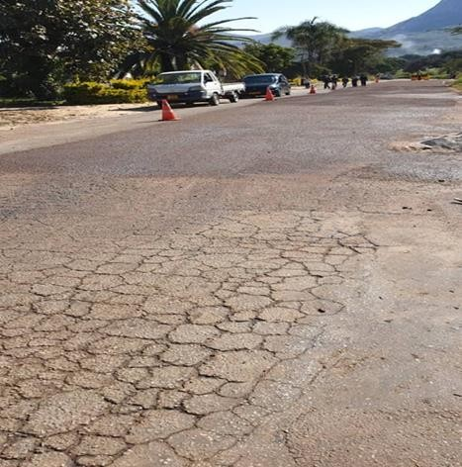

Crack sealing and slurry sealing

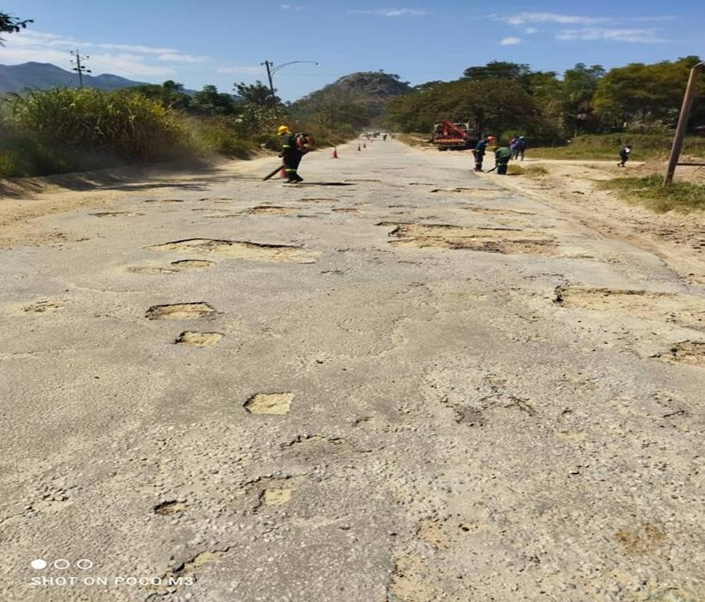

Potholes before patching

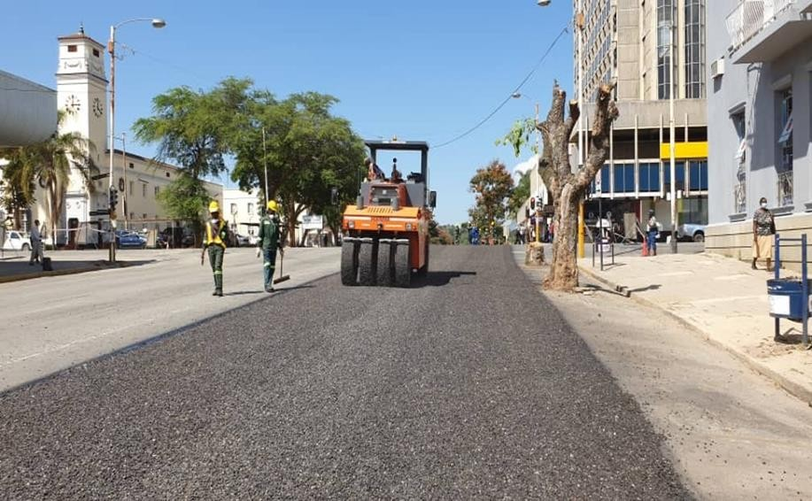

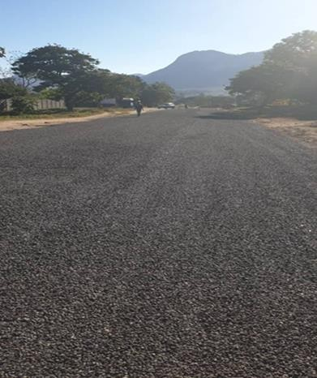

**Road condition After**

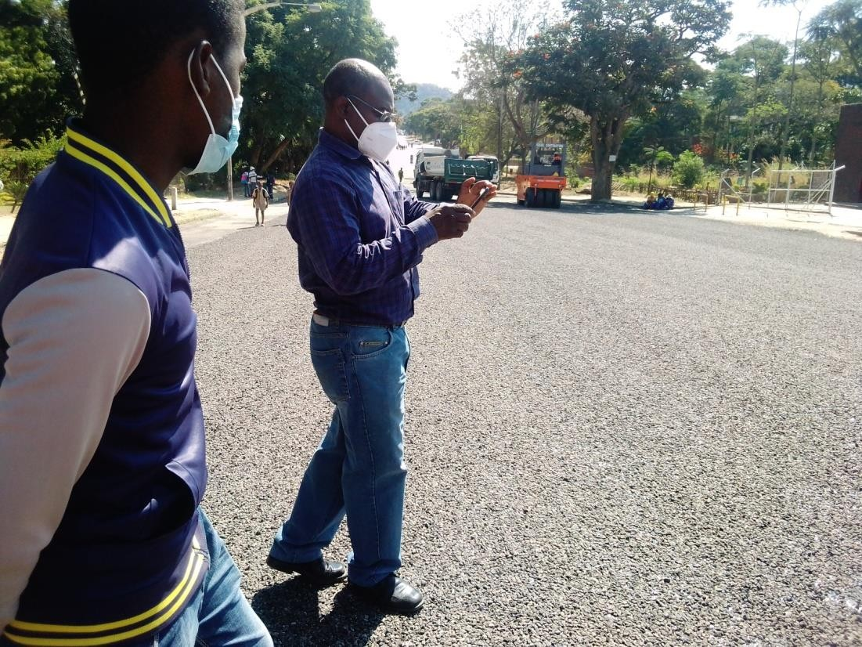

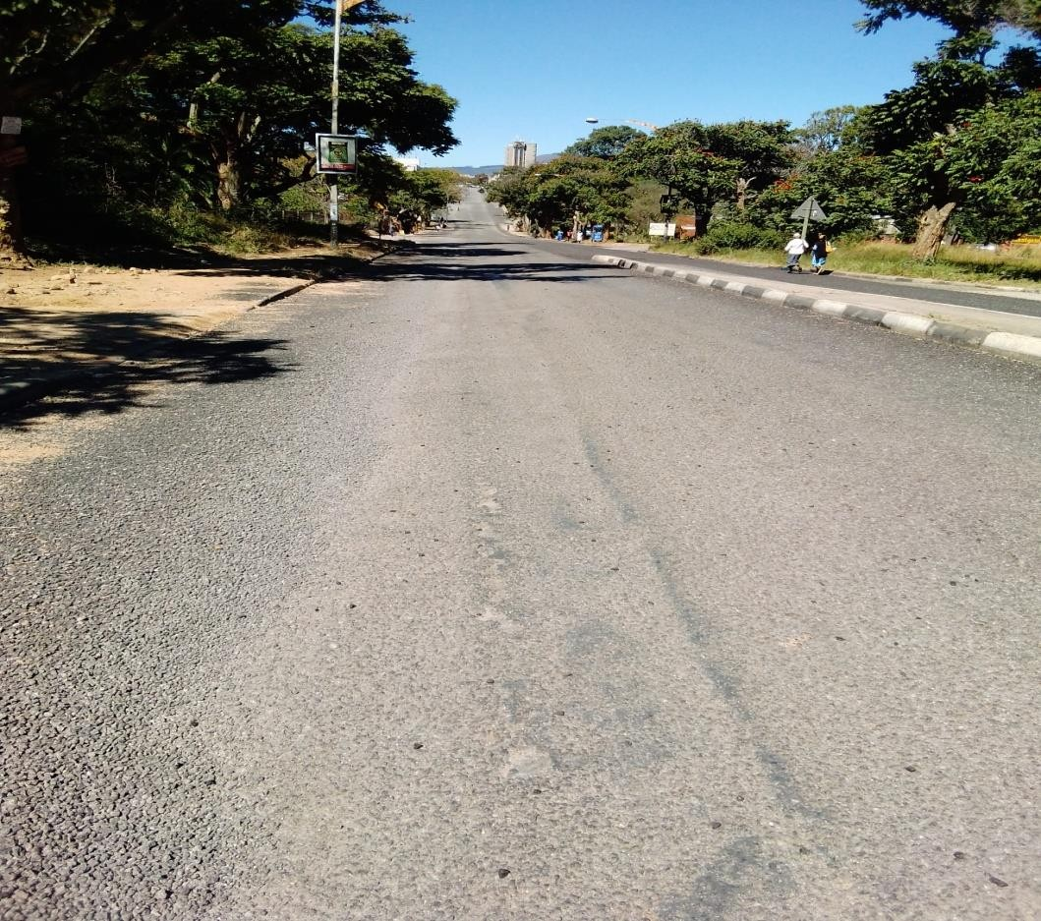

**Kumbirai Kangai**

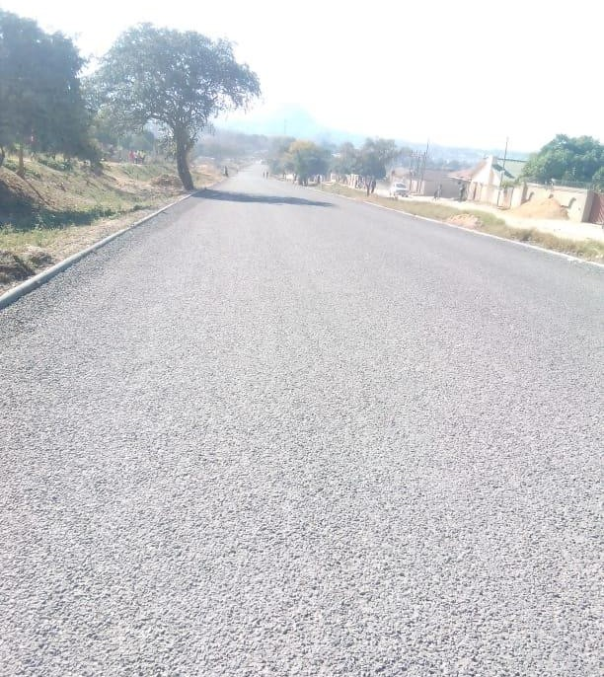

**Kumbirai Kangai road, Chikanga 2 view after works.**

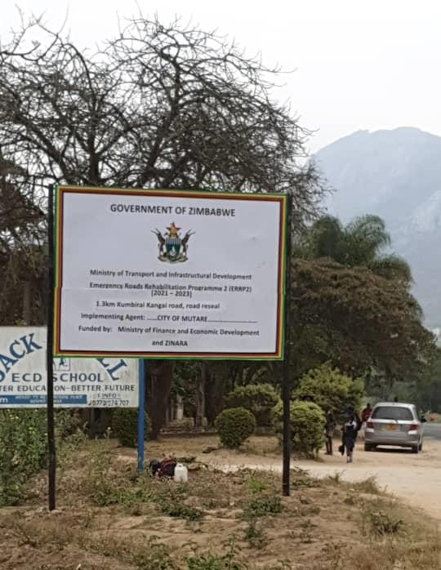

**St Joseph road**

* The road is one of the commuter routes in the City of Mutare and is 1.6 km long from Sakubva to Chikanga St Joseph area
* The road has gravel road section and a surfaced section both which are in a very poor state with galleys potholes most sections which rendered the road untrafficable.
* 2250m3 of Gravel dumping has been completed in preparation for gravelling i.e spreading a and compacting
* V drains will be opened using a grader
* Project was allocated RTGS$ 3, 179,232.00 ERRP2 phase 1

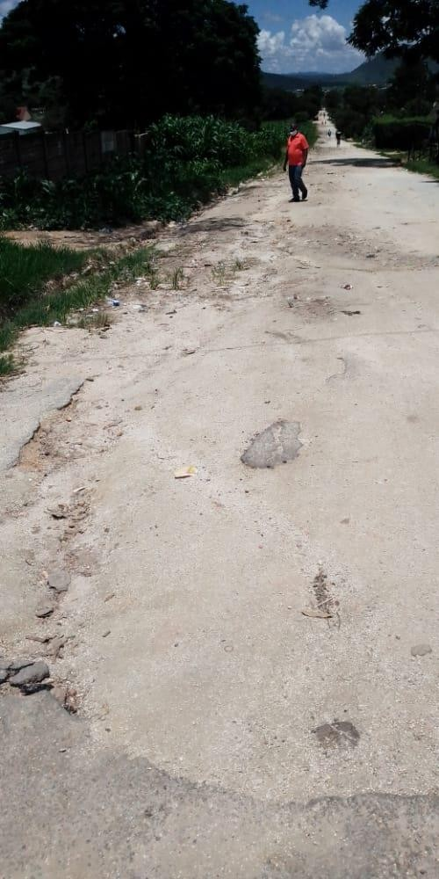

**St Joseph Before**

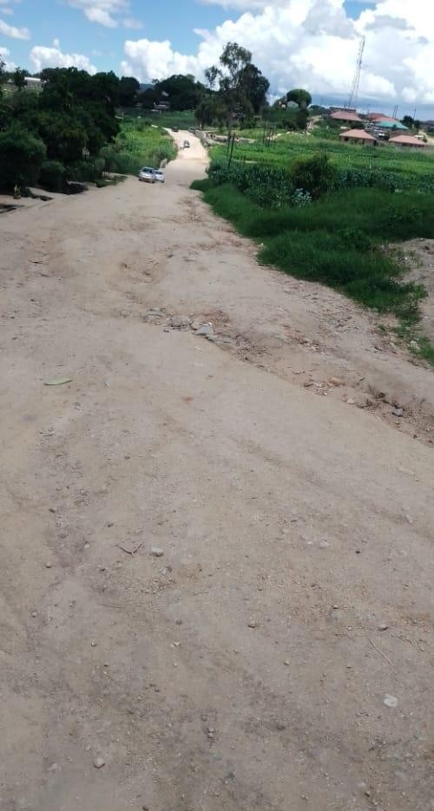

**St Joseph Before**

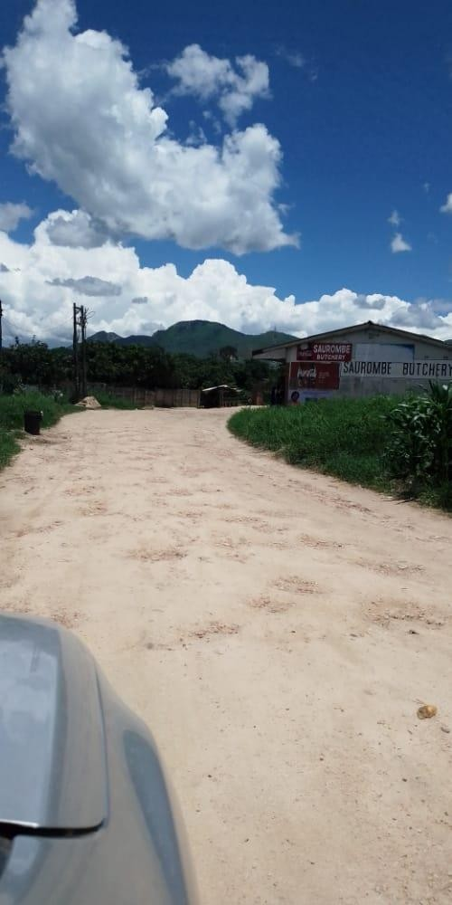

**St Joseph Before**

**Work in progress**

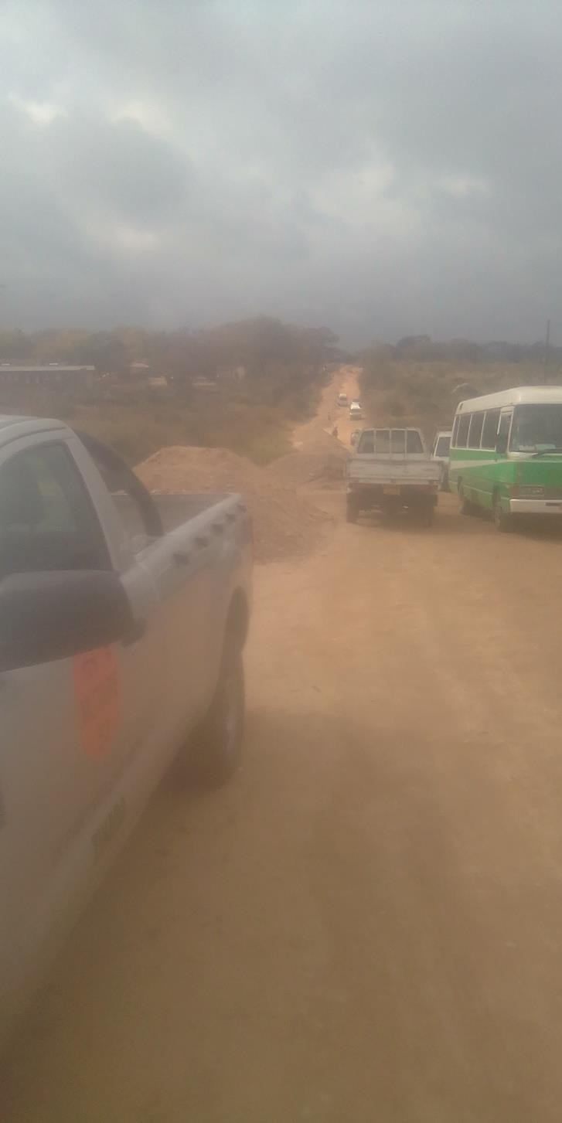

**St Joseph Work in progress**

**Feruka road**

* **Feruka road** runs for 12km linking Feruka Oil Refinery to Chimanimani road which is one of the regional truck routes. The Feruka Oil Refinery is of National strategic importance. National fuel coming from Beira via the pipeline passes through this deport with an option of fuel being transported via road dispatched from this deport to Harare and other towns. The road is a national lifeline and allowing this road to deteriorate will starve the Nation of the much needed fuel for industry and business apart from the commuting public. The road also links Dangamvura, Weirmouth and Hobhouse suburbs serving a population in excess of 100 000.
* 10.6 km of the road was in a bad state
* Cement stabilized gravel patching and tar patching has been done on 9.15km of the road and 120m3 of hot premix was used
* The project was allocated RTGS$ 11, 155, 200.00 under ERRP2 Phase 1

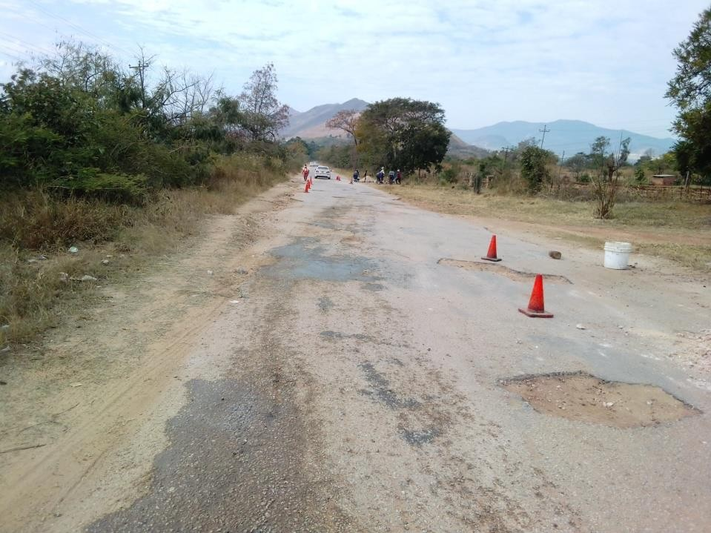

**Feruka Road Before**

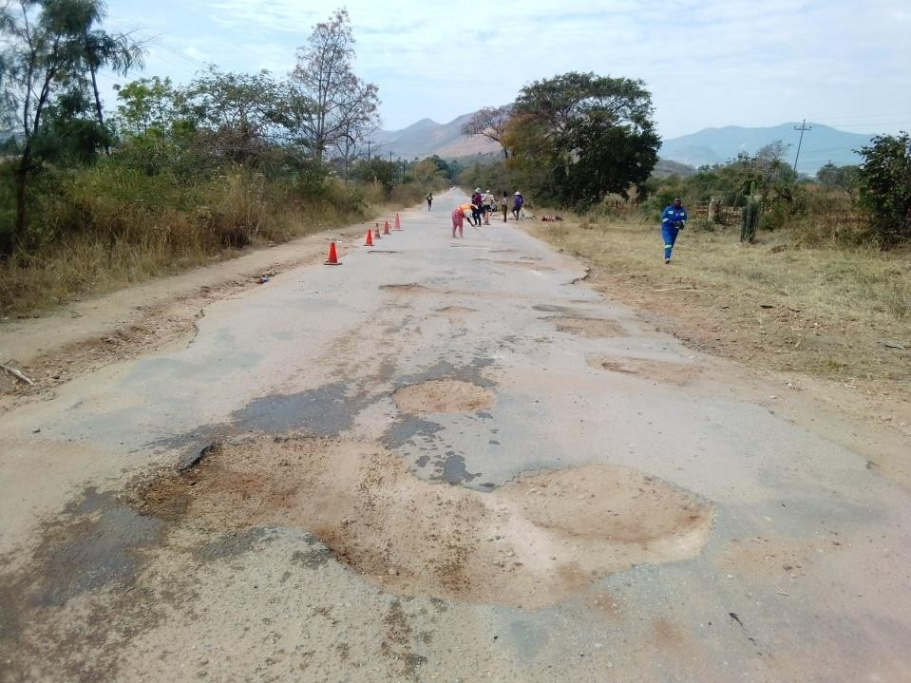

Feruka Road Before

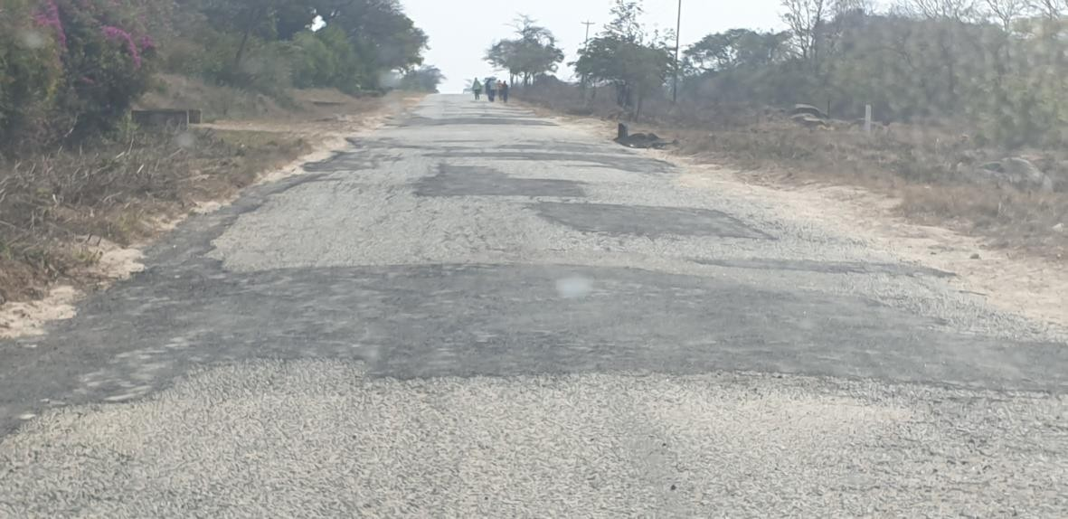

**Feruka road after**

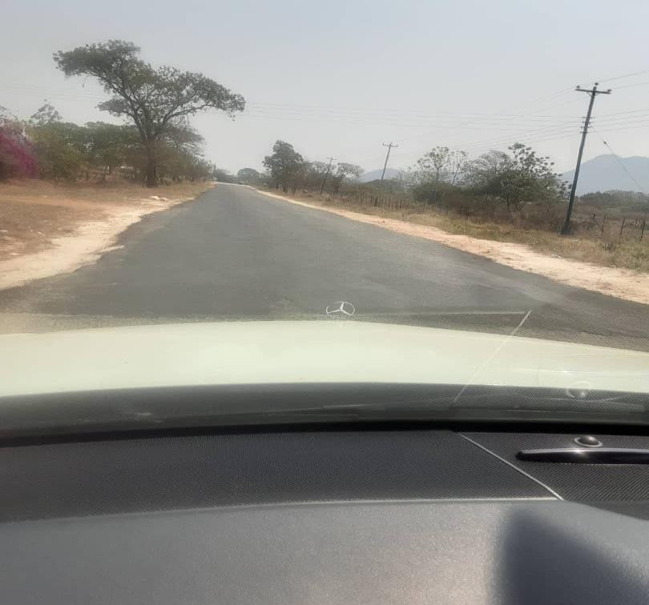

**Feruka Road After**

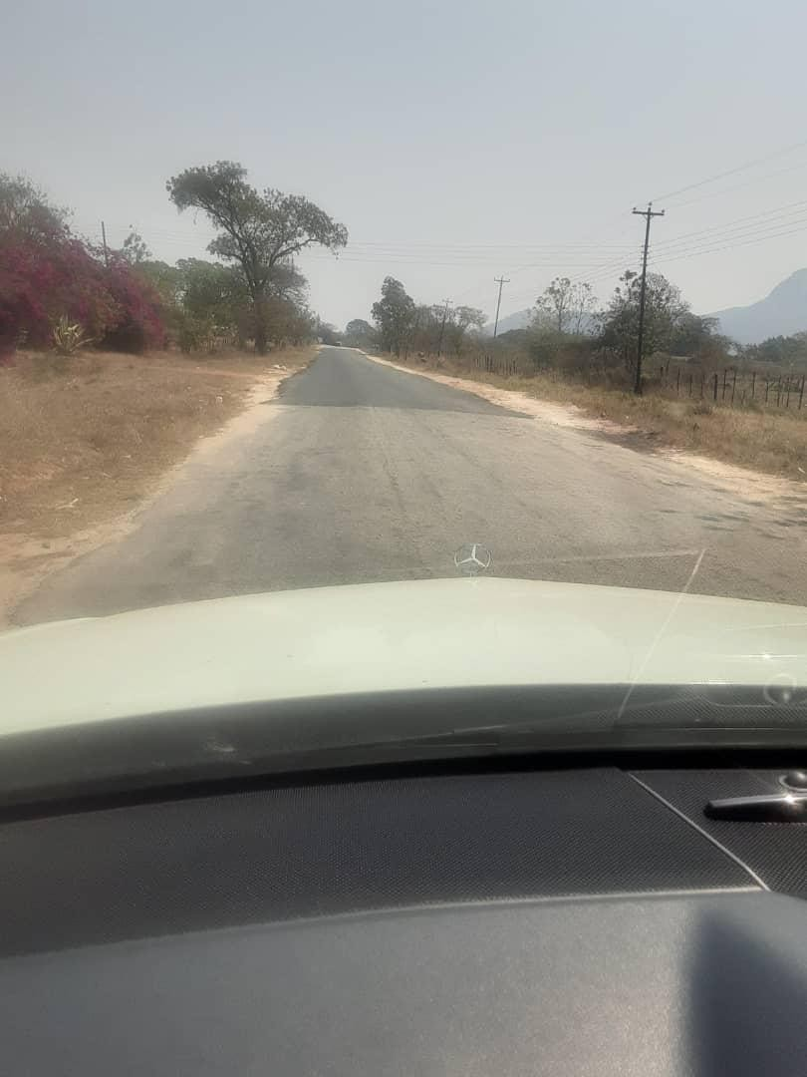

**Feruka Road after**

**Gimboki Shelvert**

* Dangamvura area 3 Shelvert bridge
* The shelvert bridge suffered erosion on the downstream side which affected the road carriage way. There has been massive undercutting and looming danger of total bridge collapse. The intended intervention works include backfilling and slope protection.
* The bridge is on a main road linking Dangamvura area 3 and Dangamvura Greenmarket and it is a vital link.
* Work is in progress and 70% embankment backfill complete

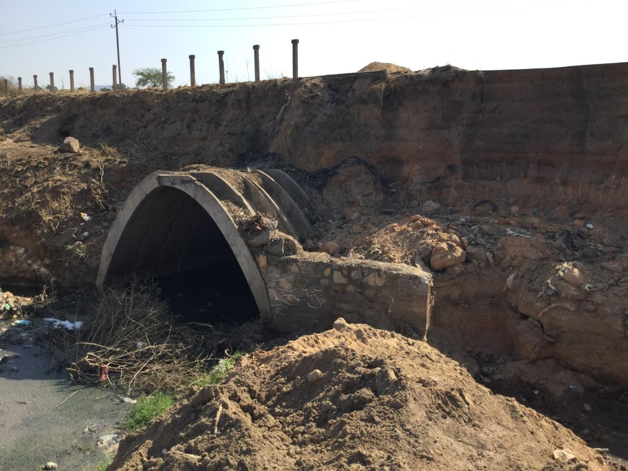

Gimboki shelvert before..

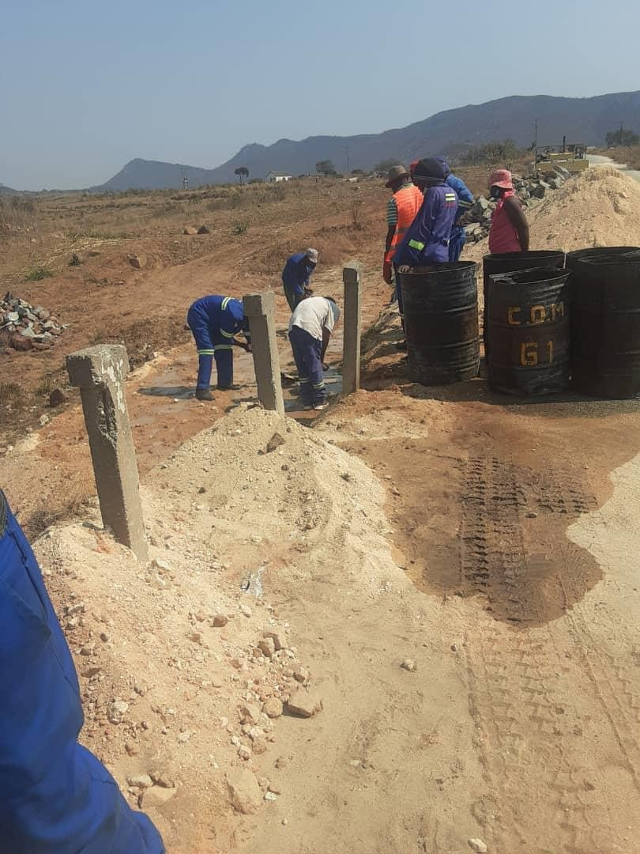

Gimboki shelvert work in Progress

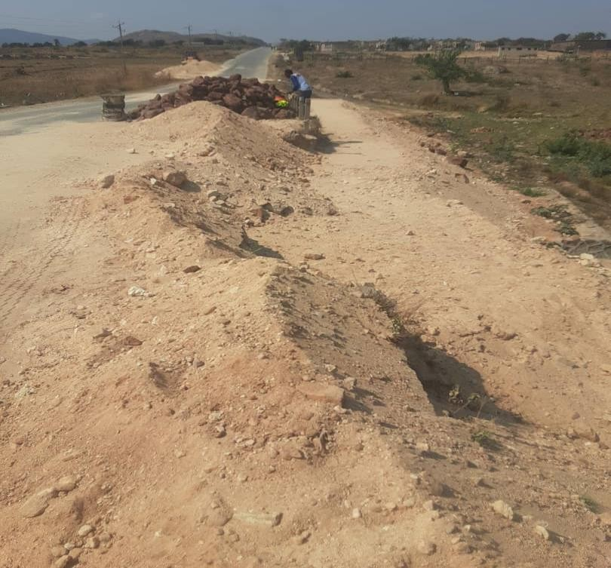

Gimboki shelvert work in Progress

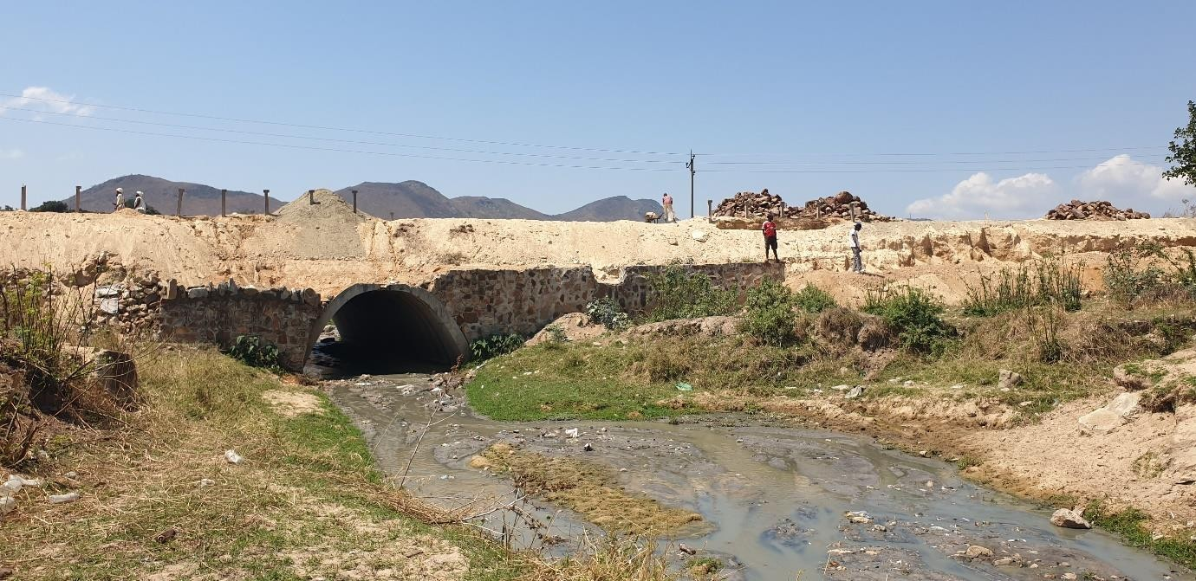

Gimboki shelvert work in Progress

**REVENUE COMPOSITION**

HEALTH GRANTS, 5,133,750.00

BEER LEVY, 2,960,339.59

NON BILLABLES, 60,672,343.10 ENDOWMENT, 698,443.71

FISCAL TRANSFERS , 7,346,637.00 WATER , 131,662,598.00

LAND SALES, 4,684,753.00

ZINARA GRANT, 10,536,086.40

MARKET FEES, 18,075,803.32

SEWER, 58,671,482.00

PARKING, 31,374,423.68

HEALTH FEES, 6,503,512.84

EMMERGENCY SERVICES, 31,897,903.31

RATES, 102,696,461.00

LICENCES, 95,036,626.68

BUILDING PLAN FEES, 22,549,445.37

REFUSE, 55,583,870.00

SUPPLEMENTARY CHARGES, 55,026,256.00

WATER SEWER RATES SUPPLEMENTARY CHARGES REFUSE BUILDING PLAN FEES LICENCES EMMERGENCY SERVICES HEALTH FEES PARKING MARKET FEES ZINARA GRANT LAND SALES FISCAL TRANSFERS NON BILLABLES HEALTH GRANTS ENDOWMENT BEER LEVY

# Consolidated Revenue by Programme

|  |  |  |  |  |  |
| --- | --- | --- | --- | --- | --- |
|  | **Budget Estimates** | **Projected Billings (Jan to June)** | **ACTUAL**  **(Own Revenue)** | **ACTUAL (GRANTS & OTHERS)** | **TOTAL REVENUE** |
| **PROGRAMMES** | amount | Amount | amount | Amount | Amount |
| Governance and  Administration | 161,355,693 | 63,104,253 | 42,012,173 |  | 42,012,173 |
| Water, Sanitation and Hygiene | 991,358,205 | 576,543,505 | 246,875,057 |  | 246,875,057 |
| Social Services | 1,011,072,019 | 245,593,175 | 176,895,170 | 5,133,750 | 182,028,920 |
| Roads | 489,338,698 | 29,771,682 | 26,920,909 | 17,882,723 | 44,803,633 |
| Public Safety and Security  Services | 1,134,434,996 | 309,472,641 | 184,562,226 |  | 184,562,226 |
| Natural Resources Conservation and Management | 5,394,600 | 828,725 | 828,725 |  | 828,725 |
| **TOTALS** | **3,792,954,212** | **1,230,785,171** | **678,094,262** | **23,016,473** | **701,110,735** |

We should invest more in improving our natural resources monitoring in order to protect our future and to harness more revenue from our natural resources. The performance of this program is very poor hence we should take action.

# REVENUE FUNDING SOURCES

REVENUE SOURCES

800,000,000.00

**678 094 262**

700,000,000.00

600,000,000.00

500,000,000.00

400,000,000.00

300,000,000.00

200,000,000.00

**, 23,016,473.00**

100,000,000.00

-

OWN REVENUE

GRANTS

Revenue from own funds contributed 97%, grants contributed 3% of the total revenue.

REVENUE DISTRIBUTION BY PROGRAMM

# EXPENDITURE SUMMARIES

|  |  |  |  |  |
| --- | --- | --- | --- | --- |
| **Expenditure** | **Budget** | **ACTUAL PERFOMANCE** | **VARIANCE** | **VARIANCE**  **%** |
|  |  |  |  |  |
| Compensation of  Employees | 440,427,023.52 | 323,792,611.74 | 116,634,411.78 | 45.89 |
| Use of Goods and Services | 880,689,960.96 | 189,069,117.30 | 691,620,843.66 | 26.79 |
| Repairs & Maintenance | 626,797,159.19 | 37,217,472.38 | 589,579,686.81 | 0.05 |
| Assets Acquisitions | 1,713,188,456.44 | 155,539,466.92 | 1,557,648,989.52 | 27.27 |
| **TOTALS** | **3,661,102,600.11** | **705,618,668.34** | **2,955,483,774.92** | **100.00** |

We need to review our figures to make them realistic. Variations noted above are an indication of over budgeting as a result of incorrect statistics. However our GIS is assisting us clean up our database and come up with correct statistics and we will refine the budget as we go. Our target is to have completed the GIS data capture by end of year 2023. We are proposing in the next budget a fully fledged GIS section independent from departments in order for us to improve its efficiency.

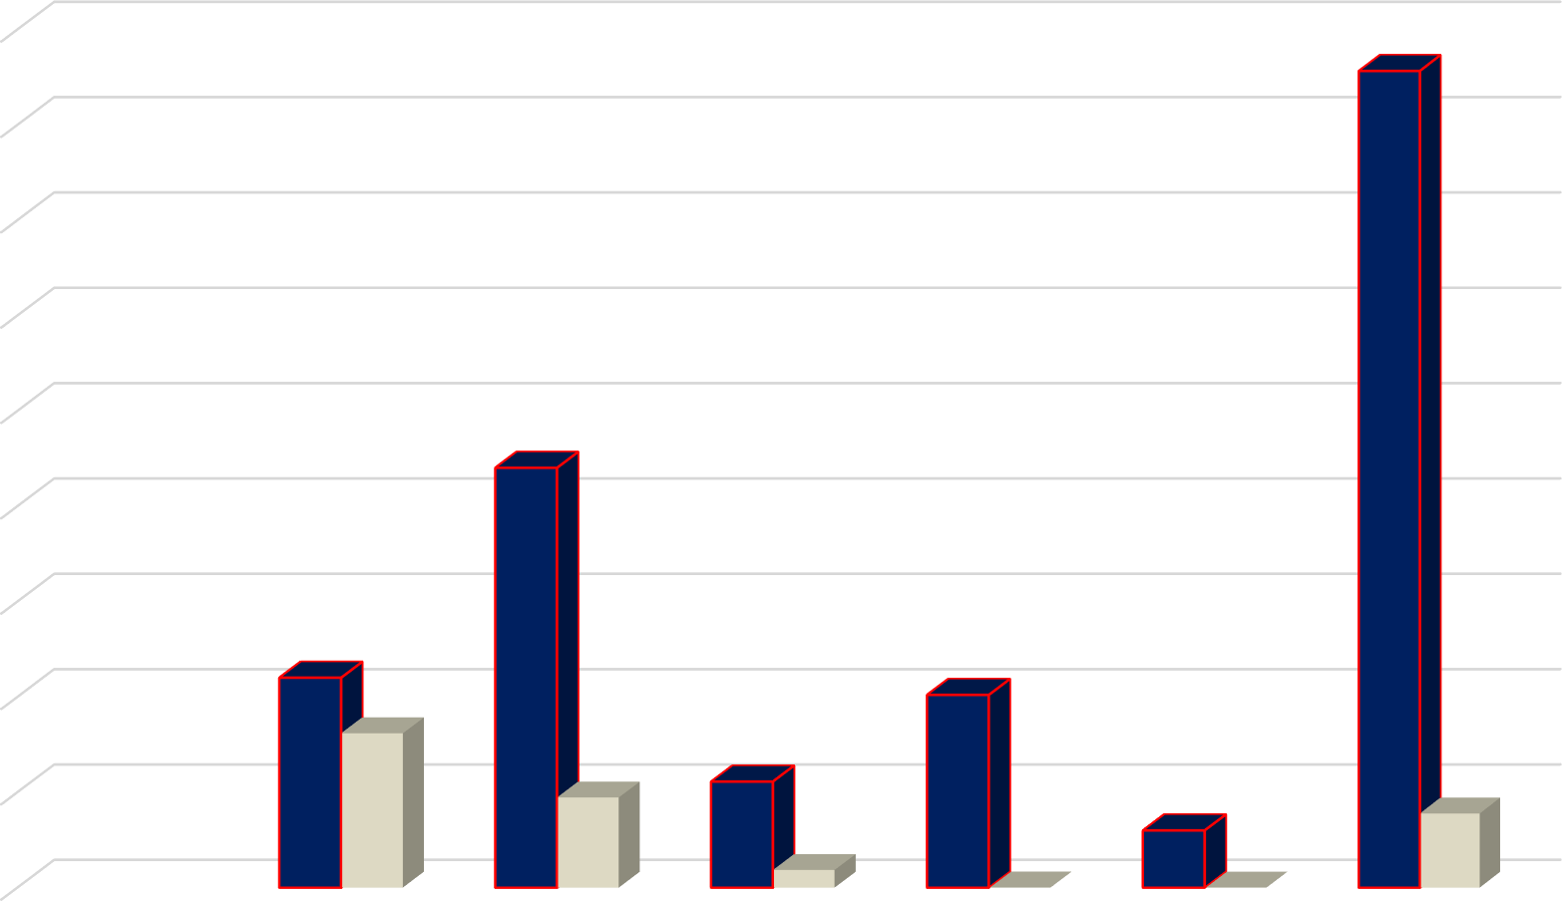

PERFORMANCE ACCRUED EXPENDITURE JAN - JUNE 2021

1,800,000,000.00

1,600,000,000.00

1,400,000,000.00

1,200,000,000.00

1,000,000,000.00

800,000,000.00

600,000,000.00

400,000,000.00

200,000,000.00

-

Compensation of Employees

Use of Goods and Services

Maintenance Repairs Consumption of

fixed capital

Assets Acquisitions

Budget ACTUAL PERFOMANCE

# SALARIES

Expenditure for salaries was $323 792 612 which consumed 45.88% of the total expenditure. We submitted a salaries budget of $440 427 034 and had budgeted for a 20% salary increase. When we submitted our budget salary for the lowest paid workers was pegged at around

$5000 which is no longer sustainable. Due to inflation and the economic instability in the country, we had to increase salaries for workers. By the end of the first half of the year salaries expenditure consumed 71.51% of the total salaries budget.

We managed to clear off the debt of $21m that we had with LAPF and we are committed to paying off our monthly bills as they fall due. Our net salaries are up to date.

We have managed to provide our junior staff members a competitive salary in relation to our sector, however the salary has remained low as compared to the inflation levels. Without a budget tariff increase it has become impossible to give our employees a meaningful salary increase but we have kept engagements between the employees and employer very active in order to facilitate dialogue for mutually agreed position on way forward. As a result a supplementary tariff adjustment is the only way out and proposals are coming in for adjustment of non billables effective 1 November 2021. The adjustment can also include industry and commerce billables and will be implemented by way of a resolution after consultations.

# OPERATIONAL COSTS

Operational costs were $189,069 117.30 and took 26, 79% of the total expenses. The economic instability in the country remains a challenge and is impacting on service delivery. All our suppliers are rating on the basis of parallel US$ value every time there is movement in the parallel forex market. Our inputs costs have increased in worst cases by 3 times due to unstable forex market. Service delivery is no longer sustainable.

The main cost drivers for Council in the period ending 30 June 2021 were:

* + Fuels
  + Electricity
  + Water Chemicals
  + Water Extraction Charges

# CAPITAL EXPENDITURE

Capital expenditure took 22.04% of the total expenditure which was $705,753,668.34 as at 30 June 2021. We however registered positive strides in the following selected projects:

1- Procurement of tippers*2 and expect delivery of a motorized Grader & an iron roller before end of August 2- Fencing of Aerodrome

1. GIS Mapping
2. Industrial drain rods
3. Procurement of 10 utility Vehicles
4. Procurement of ICT Servers & computers 7- Maonde electrification
5. In-line chlorinators for T section
6. Construction of new public toilet Dangamvura cemetery 10- Procurement of new movable goal Sakubva Stadium

11- Sakubva stadium tunnel and changing rooms 12- 2 *Rottery mowers for parks and gardens

1. 3.7km Magamba drive road reseal/ reconstruction
2. 31.9km Tar pothole patching of various CBD and main roads (Herbet Chitepo, 2nd St, Leopold Takawira, Feruka rd, St Joseph rd)
3. 4.3km Kumbirai Kangai (Aerodrome rd) road reseal. 16- 2km Musikavanhu Drive (Dangamvura rd) reseal
4. 1.6km gravelling Chikanga St Joseph road
5. An ambulance and we still expect one more before year end 19- 2 Equipment for Gimboki Clinic

20- 10*Colour droppler fetal monitor 21- Fire Engine

1. Command Vehicle
2. Equipment for City & Sakubva Health Care Clinic 24- Sakubva & Chidzere flea market fencing.

25- We have running tender for 2 new refuse trucks, 2 water bowsers and a an excavator 26- We also procured 2, 4 tonne trucks for parks and engineering.



# CAPITAL EXPENDITURE FUNDING STRUCTURE

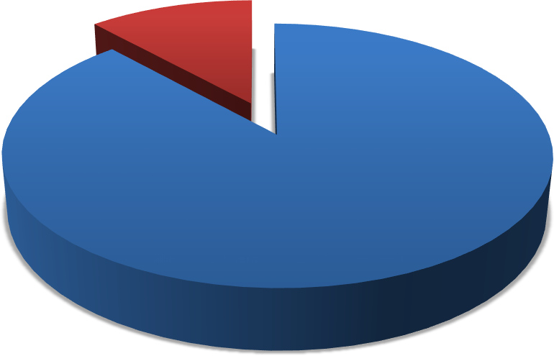

**FUNDING SOURCES**

GRANTS, 18,179,723.40 ,

OWN REVENUE,

137,359,743.52 , 88%

OWN REVENUE GRANTS

**DONATIONS**

We received the following items through donations. Most donations came in for Covid -19

|  |  |  |  |
| --- | --- | --- | --- |
| **DONOR** | **ITEMS** | **VALUE** | **RECEIVING DEPARTMENT** |
| Common Wealth | 4 DESKTOP COMPUTERS & 1 LAPTOP | 926,900.61 | Housing & Community  Services |
| Mutare District Phamacy | COVID -19 TEST KITS | 1,962.88 | Pharmacy |
| MPH | COVID -19 TEST KITS | 47,779.59 | Pharmacy |
| PMD | PCR Test kit | 26,456.19 | Rapid response team |
| MPH | MEDICAL DRUGS | 4,652.05 | Pharmacy |
| Every Life matters Funds | Brush cutter twine | 9,921.07 | Health Depot |
| MPH | Covid-19 antigen test kit B/25 | 4,652.05 | Pharmacy |
| Tanganda Tea | PROTECTIVE CLOTHING | 30,813.55 | Grave Diggers(Housing) |
| Global Hope Mobilization | medical equipment | 208,508.37 | MIDH |
| MPH | Medical drugs and test kits | 243,235.59 | Pharmacy |
| GGZT | Dish washer (5l) | 5,000.47 | City Health Department |
| WLSA | sanitizes, soaps sanitary pads | 19,574.71 | City Health Department |
| Sakubva Helper UK | 650 Fiction and non fiction books | 58,799.52 | Library |

|  |  |  |  |
| --- | --- | --- | --- |
| Every Life matters Funds | brush cutters, stretcher beds mattresses | 289,223.28 | MIDH |
| WHO | SKM Motor cycle with accessories | 329,176.80 | City Health Department |
| AHF | desks, chairs, printer, projecter, iter 56, benches  cabinet | 649,915.12 | SOPD |
| Every Life matters Funds | Standard Bedside lockers | 125,835.00 | MIDH |
| MOHCC/ICAAP | sumsung galaxy tablets A65*9 | 2,003,293.20 | Clinics |
| Mutare District Pharmacy | disposable gowns, sanitizers | 43,287.24 | Pharmacy |
| Idai Recovery Project | medical equipment | 48,991.76 | Pharmacy |
| Comhold | scour blowers and airconditioner | 7,907,925.24 | Odzani and Gimboki |
| Common wealth local Government  Forum | hp destop and hp laptop | 926,900.61 | Housing LADS implementation |
| Natpharm | Acyclovir 200mg | 12,751.28 | Pharmacy |
| UNICEF | Hand sanitizer 500mls | 251,670.00 | MIDH |
| MoHCC | Penguins | 80,620.80 | Civic center Health  Department |
| CeSHHAR | face masks, sanitizers,rescue blankets | 289,563.04 | Sakubva Clinic |
| MSF-Belgium Project | medical equipment | 2,228,017.95 | Pharmacy |
| Nathaniel Machini | 100 Fiction Books | 16,823.94 | Library |
| Care International | 3 Tippy tappy buckets | 21,955.24 | Housing |

|  |  |  |  |
| --- | --- | --- | --- |
| MPH | Covid-19 antigen test kit B/25 | 9,452.46 | Pharmacy |
| MoHCC | Solar flood lights | 2,196.55 | Dangamvura Clinic |
| Mr Fon and Seven sisters | Royal Cuban Palm trees | 13,517.22 | Dangamvura Clinic |
| Dangamvura East UMC RRW | pine gels . Dish washing liquid | 1,605.17 | Dangamvura Clinic |
| Life international Zimbabwe | Office Chairs | 76,920.66 | Dangamvura Clinic |
| Mohcc through UNDP | 15 Panel solar | 7,352.26 | Sakubva Health Center |
| PMD | 20l diesel | 2,231.54 | Civic center Health  Department |
| WHO ZIRP Project | Surgical face masks B/50 | 825,840.51 | Pharmacy |
| MPH | Covid-19 antigen test kit B/25 | 4,399.93 | Pharmacy |
| Mercy Corps | Surgical face masks B/50 | 13,967.15 | City Health Department |
| Care International | Covid 19 sensitisation billboard | 17,482.50 | Housing Sensitisation |
| DA's Office | Tippy tap bucket | 7,329.75 | Housing |
| Kufema Zimbabwe | Oxygen respirators | 31,968.75 | MIDH |
| PMD | Diesel coupons | 87,978.00 | City Health Department |
| Mutare Bottling Company | Sprite cans 330mls | 4,140.00 | Chamber Secretary |
| Kufema Zimbabwe | Oxera Kit | 19,239.68 | Housing Sensitisation |

|  |  |  |  |
| --- | --- | --- | --- |
| Corpaid | Corpaid | 4,446.50 | Housing |
| NAC | Water based lubricants | 487,405.29 | MIDH |
| **Total** |  | **18,431,681.11** |  |

# ACCOUNTS RECEIVABLES

Below is our Debtor’s analysis as at 30 June 2021. The level of debtors confirms that there is growing need for Council to intensify debt collection in order to reduce these debtors. We also have dormant debtors whose accounts are not serviced which the legal section should pursue and finalize. We are working with our credit control team to separate problem clients from the rest so that these are pursued separately and require different approach from the rest. Our major Debtor is Mutasa RDC who only paid $3 million in the current year out of a total billing of $69 million on the date of this report. We have instructed our new lawyers to demand payment and this has already been done and we await to see how they will defend. Their failure to pay for water supplied compromised our capacity to provide water on a daily basis hence we have started to ration Mutasa RDC and other selected areas within our city.



**DEBTORS TREND**

900,000,000.00

800,000,000.00

829,439,406.01

700,000,000.00

721,612,510.00

600,000,000.00

779,631,393.62

664,537,001.00

832,184,570.63

500,000,000.00

571,131,451.89

400,000,000.00

300,000,000.00

200,000,000.00

100,000,000.00

-

JANUARY

FEBRUARY

MARCH

APRIL

MAY

JUNE

The increase in tariffs in January 2021 compounded by poor macro-economic performance induced by Covid-19 prevailing in the country resulted in poor budget performance. Debtor’s figures are on the rise. In the first quarter the closing figure for debtors was well over $721 million. By close of June the figure rose by an estimated 15 % to close the quarter at over $832 million. Although debtors have been increasing , we however managed to reduce the rate of increase. From our billing we are collecting an average of 70% and this means the 30% uncollected increases our debtors’ balance. We are employing more strategies to enforce for collection and our first batch of summons were served and the messager of court is busy executing for recovery. This is sending signals to residents that council dues should be paid and we have seen some coming in for payment plan arrangements with our debt collection team. We hope our collection efficiency continues to improve every month as shown in the upward collection trend from 25% in January to June 70%. This is very impressive performance especially when you consider the tough COVID environment. We should continuously capacitate our revenue team to continue in this trajectory.

# CREDITORS AGE ANALYSIS AS AT 30 JUNE

CREDITORS TREND

18,000,000.00

16,312,606.70

16,000,000.00

14,000,000.00

13,465,031.00

12,000,000.00

10,938,032.54

10,000,000.00

9,719,934.00

8,000,000.00

9,263,879.00

6,000,000.00

7,818,990.00

4,000,000.00

2,000,000.00

-

JANUARY

FEBRUARY

MARCH

APRIL

MAY

JUNE

Our creditors increased by from $10 ,9million in first quarter to $16,3 million by end of the second quarter which is a 67% increase, with major creditors being:

* Pungwe subcatcment
* Zimbabwe insurance brokers(ZIB)
* ZINWA

However these creditors’ (ZIB and ZINWA) balance are in current in terms of aging and are not overdue since the current charges are paid off before end of the following month of receiving bills. We however have not paid Pungwe for 2021 invoice mainly because of sticky issues around water that is consumed through Tsonzo & Sakupwanya Offtakes in Mutasa district for rural communities. We have engaged Pungwe sub catchment to revise our bill to remove that which relates to raw water consumed in Mutasa by rural consumers. We have not reached an agreement yet but as soon as this is finalised we will pay off.

We have a very positive current ratio due to very low liabilities which give confidence and confirms our going concern status as very healthy. More still needs to be done to reduce debtor’s levels.

# BUDGET PERFORMANCE BY DEPT FINANCE

|  |  |  |
| --- | --- | --- |
| **PROJECTS** | **Section** | **Progress** |
| Motor Vehicles- 1 New vehicle | Stores Section | 1 vehicle was delivered for stores section and one more new vehicle & 15 motor bikes are expected by year end |
| Furniture & Fittings | Several sections | Procured for several offices and Dangamvura new offices |
| Meter reading & Receipting Gadgets | Revenue Section | On Tender |
| Computer Equipment | All Finance Sub-sections | Procured |
| Self Service Smart Gadgets | Meter readers | Deferred to next year |
| Banking Hall Renovations | Revenue | Tender failed. Retendered targeting first quarter 2022 |
| Systems Integration ( Promun, LADS etc) | All Sections | Partially done. Axis not opening up promun |

|  |  |  |
| --- | --- | --- |
| LADS new modules | All Sections | New Lads lab to be opened |
| NEW ERP | All Sections | New ERP to be developed with partial funding from CLGF |
|  |  |  |

**HOUSING & COMMUNITY SERVICES DEPARTMENTAL PERFOMANCE REPORT 2021**

**KEY PROJECTS AND ITEMS PROCURED**

|  |  |  |  |
| --- | --- | --- | --- |
| **NO** | **ITEM** | **SECTION** | **STATUS** |
| **1** | Executive Vehicle | Admin | Procured |
| **2** | Heavy duty Printers * 2 | Admin | Procured |
| **3** | Construction of public toilet – D/Mvura cemetery | Parks | Work in progress |
| **4** | Stadium | Com services | +90% Completion |
| **5** | Bush Mower | Parks | Procured |
| **6** | Rotary Mower | Parks | Procured |
| **7** | 3 Desk Computers & 1 Laptop | Housing | Donated |
| **8** | 3 Ton lorry | Parks | Procured |
| **9** | Chain Saw*2 | Parks | Procured |

|  |  |  |  |
| --- | --- | --- | --- |
| **10** | TV | Stadium | Procured |

The above items have been procured to date, with some of items being received end of December/Early January. Key milestones include;

* The 3 ton truck was recently procured will go a long way in addressing perennial transport challenges for the Parks section, which is charged with greening of the city parks and gardens, grass and tree cutting and cemetery management. Most of the tasks include ferrying goods and personnel to various workstations across the city. A reflection of the dire situation include the front page picture when our staff were pictured being transported sitting on a loan mower.
* The procurement of a bush mower has enabled the Parks section to attend to overgrown grass within a reduced period, while the Rotary mower is enabling the timeous mowing of lawn at the stadium.
* The Department had no printer and had to rely on 1 printer stationed at the LGA Accountant’s office. This was untenable given the volumes of printing the department undertakes on day to day basis.
* The Department also received 4 high specs computers from CLGF for the implementation of LADS.
* The Stadium was re-opened following an assessment by PSL and few matches were also hosted owing to major investments towards the refurbishment of the stadium.
* The Department also managed to repair a number of houses in Sakubva which had been damaged by rain.
* Markets have also been constructed and rehabilitated using Council resources as well as support from partner.

|  |  |  |  |
| --- | --- | --- | --- |
| **2021 FAILED PROJECTS** |  | **SECTION** | **ACTION** |
|  |  |  |  |
| Servicing Of Stands | Servicing of stands |  | DEFERRED TO 2022 |
| Jojo tank and borehole sinking |  |  | DEFERRED TO 2022 |
| Motor Vehicle |  | Vehicle for District Officer | DEFERRED TO 2022 |
| Executive desks |  | Director/DD/Secretary | DEFERRED TO 2022 |
| Executive chair swivel -Director |  |  | DEFERRED TO 2022 |
| Filling Cabinets |  | Registry | DEFERRED TO 2022 |
| Office Desk |  | For District Officer | DEFERRED TO 2022 |
| Office chairs |  |  | DEFERRED TO 2022 |
| Tea urn |  |  | DEFERRED TO 2022 |
| Visitors chairs(Director's office) |  |  | DEFERRED TO 2022 |
| Visitors Chairs |  | For District Officer | DEFERRED TO 2022 |
| Visitors Chairs |  | For District Officer | DEFERRED TO 2022 |
| Laptops for DO/Budget/CSO/AD |  | District Officer | DEFERRED TO 2022 |
| Printer Laser Jet M277N |  | District Officer | DEFERRED TO 2022 |
| Reconstruct public toilet and kitchen |  |  | DEFERRED TO 2022 |
| Sliding Gate |  | Sliding Gate For Main Entrance | DEFERRED TO 2022 |
| Chikanga office renovations |  |  | DEFERRED TO 2022 |
| Boundary Wall | Boundary wall for Csd Admin |  | DEFERRED TO 2022 |
| Construction Of Toilet And Kitchen | Construction of toilet and kitchen |  | DEFERRED TO 2022 |
| chairs |  | 450 chairs | DEFERRED TO 2022 |
| chairs |  | 4 visitors | DEFERRED TO 2022 |
| desks |  | 6 desks | DEFERRED TO 2022 |
| pa system |  | sakubva stadium | DEFERRED TO 2022 |
| computer |  | Office | DEFERRED TO 2022 |
| football pich |  | rehabillitation to turf | DEFERRED TO 2022 |
| goal post |  | Movable | DEFERRED TO 2022 |
| BOOK SHELVES |  | LOCKABLE | DEFERRED TO 2022 |
| CHAIRS |  | SWIVEL, JUNIOUR CHAIRS, VISITORS CAHIRS | DEFERRED TO 2022 |
| DESKS |  | LOCKABLE | DEFERRED TO 2022 |
| TABLES |  | FOR JUNIORS | DEFERRED TO 2022 |
| COMPUTERS |  | COMPUTER EQUIPMENT | DEFERRED TO 2022 |
| AREA016 |  | SERVICING | DEFERRED TO 2022 |
| AREA 3 |  | SERVICING | DEFERRED TO 2022 |
| MARKETS CONSTRUCTION |  | NEW MARKET | DEFERRED TO 2022 |
| SAKUBVA STADIUM |  | CONSTRUCTION | DEFERRED TO 2022 |
| BOUNDARY WALL |  | CHISAMBA GROUNDS | DEFERRED TO 2022 |
| CHIKANGA MULTI PURPOSE CENTRE |  | MULTIPURPOSE CENTRE | DEFERRED TO 2022 |
| FACTORY SHELL |  | COSTRUCTION | DEFERRED TO 2022 |
| NEW FLEA MARKET |  | CHIKANGA FLEA MKT BRICK BOUNDARY WALL | DEFERRED TO 2022 |
| STANDS SERVICING |  | BOTS AND BLOCK YARD | DEFERRED TO 2022 |
| GIMBOKI PRI |  | CONSTRUCTION OF PRIMARY SCH | DEFERRED TO 2022 |
| tables and chairs |  | meikels park | DEFERRED TO 2022 |
| tipping trailer |  | grass cutting | DEFERRED TO 2022 |
| tractor |  | heavy duty with accesories | DEFERRED TO 2022 |
| boom gate and guard room |  | lions view | DEFERRED TO 2022 |
| borehole |  | meikels park | DEFERRED TO 2022 |
| boundary wall |  | caravan park | DEFERRED TO 2022 |
| gazebo |  | meikels park caravan park | DEFERRED TO 2022 |
| jojo tank |  | meikels park | DEFERRED TO 2022 |

**CHALLENGES**

The major challenges facing the Department is shortage of tools of trade. The shortage of transport will remain a challenge for the Department which will impact negatively on service delivery. The Department is only serviced by two trucks where four should be the minimum. Council Cemeteries lack WASH facilities. The Toilet at Dangamvura cemetery is yet to be completed, and clients and citizens practicing open defecation. The Crematorium, at Yeovil cemetery is yet to be repaired as well.

While markets have been either constructed or rehabilitated, more resources are required as council pushes for decentralization in view of Covid-19.

Low and unsustainable tariffs on rented properties remains a big challenge. With most properties in Sakubva requiring major refurbishments due to decay over years, there is need to charge sustainable tariffs.

**EXPECTATION BEFORE YEAR END**

The following project are expected to be implemented before year end;

* Renovations/Repair of Housing Admin Offices
* Completion of the Public Toilet at Dangamvura Cemetery
* Digitization of Housing files in the registry
* Procure of Water pump for cemetery
* Roof construction at Hobhouse Primary School
* Turf upgrading (Sakubva Stadium)

**HEALTH DEPARTMENT**

|  |  |  |  |
| --- | --- | --- | --- |
| **HEALTH SERVICE DEPARTMENT CAPITAL EXPENDITURE BUDGET:2021** |  |  |  |
| **ITEM** | **QUANTIT Y** | **STATUS** | **COMMENT** |
| **FIRE AND EMERGENCIES DIVISION** |  |  |  |
| Fire engine | 1 | Procurement processes ongoing | Tender for two fire tenders was re- advertised |
| Utility vehicle | 1 | FAILED IN 2021 | deferred to 2022 |
| Command vehicle | 1 | PROCURED |  |
| Desktops with printers | 3 | PROCURED |  |
| ADSL internet connectivity | 1 | Procurement processes ongoing | Tender was advertised to include private sector service providers |
| Laptop | 1 | PROCURED |  |
| Phased Construction Dangamvura Sub-Station 1 |  | FAILED IN 2021 | deferred to 2022 |
| **SUB TOTAL** |  |  |  |
| **CLINICAL SERVICES** |  |  |  |
| **CHIKANGA CLINIC** |  |  |  |
| Desktop computer+ printer | 1 | PENDING | requisitions raised for procurement |
| internet connectivity | 1 | FAILED IN 2021 | deferred to 2022 |

|  |  |  |  |
| --- | --- | --- | --- |
| drug trolley | 1 | PENDING | requisitions to be raised for 2021 procurement |
| upright fridge | 1 | PENDING | requisitions to be raised for 2021 procurement |
| **SUB TOTAL** |  |  |  |
|  |  |  |  |
| **CITY CLINIC** |  |  |  |
| Desk top computer + printer | 1 | FAILED IN 2021 | deferred to 2022 |
| internet connectivity | 1 | FAILED IN 2021 | deferred to 2022 |
| examination couch | 1 | PENDING | requisitions to be raised for 2021 procurement |
| stretcher bed | 1 | PENDING | requisitions to be raised for 2021 procurement |
| wheelchairs | 1 | PROCURED | 2 wheelchairs were procured |
| visitors chairs | 5 | PENDING | requisitions to be raised for 2021 procurement |
| drug trolley | 1 | FAILED IN 2021 | deferred to 2022 |
| office desks | 2 | FAILED IN 2021 | deferred to 2022 |
| **SUB TOTAL** |  |  |  |
| **FLORIDA CLINIC** |  |  |  |
| desk top computer + printer | 1 | FAILED IN 2021 | deferred to 2022 |

|  |  |  |  |
| --- | --- | --- | --- |
| internet connectivity | 1 | FAILED IN 2021 | deferred to 2022 |
| examination couch | 1 | PENDING | requisitions to be raised for 2021 procurement |
| stretcher bed | 1 | PENDING | requisitions to be raised for 2021 procurement |
| drug trolley | 1 | PENDING | requisitions to be raised for 2021 procurement |
| wheelchairs | 1 | PENDING | requisitions to be raised for 2021 procurement |
| visitors chairs | 5 | FAILED IN 2021 | deferred to 2022 |
| office desks | 3 | FAILED IN 2021 | deferred to 2022 |
| **SHC** |  |  |  |
| CSSD TABLE | 1 | FAILED IN 2021 | deferred to 2022 |
| desktop computer + printer | 1 | PENDING | requisitions raised for procurement |
| internet connectivity | 1 | FAILED IN 2021 | deferred to 2022 |
| visitors chairs | 5 | FAILED IN 2021 | deferred to 2022 |
| stretcher bed | 1 | PROCURED | requisitions to be raised for 2021 procurement |

|  |  |  |  |
| --- | --- | --- | --- |
| drug trolley | 1 | PENDING | requisitions to be raised for 2021 procurement |
| upright fridge(290 L) | 1 | PENDING | requisitions to be raised for 2021 procurement |
| **DANGAMVURA POLYCLINIC** |  |  |  |
| internet connectivity | 1 | FAILED IN 2021 | deferred to 2022 |
| examination couch | 1 | PENDING | requisitions to be raised for 2021 procurement |
| upright fridge(290 L) | 1 | DELIVERED | From MIDH |
| drug trolley | 1 | PENDING | requisitions to be raised for 2021 procurement |
| examination couches | 1 | PENDING | requisitions to be raised for 2021 procurement |
| wheel chair | 1 | PENDING | requisitions to be raised for 2021 procurement |
| 5 plate industrial stove | 1 | FAILED IN 2021 | Deferred to 2022 |
| **SUB TOTAL** |  |  |  |
| **HOBHOUSE CLINIC** |  |  |  |
| desk top computer + printer | 1 | FAILED IN 2021 | deferred to 2022 |
| examination couch | 1 | PENDING | requisitions to be raised for 2021 procurement |

|  |  |  |  |
| --- | --- | --- | --- |
| upright fridge(290 L) | 1 | PENDING | requisitions to be raised for 2021 procurement |
| wheel chair | 1 | PENDING | requisitions to be raised for 2021 procurement |
| visitors chairs | 5 | FAILED IN 2021 | deferred to 2022 |
| drug trolley | 1 | PENDING | requisitions to be raised for 2021 procurement |
| office desks | 5 | FAILED IN 2021 | deferred to 2022 |
| **FERN VALLEY** |  |  |  |
| drug trolley | 1 | PENDING | requisitions to be raised for 2021 procurement |
| desk top printer | 1 | FAILED IN 2021 | deferred to 2022 |
| internet connectivity | 1 | FAILED IN 2021 | deferred to 2022 |
| **MIDH** |  |  |  |
| internet connectivity | 1 | FAILED IN 2021 | deferred to 2022 |
| construction of 2 guardrooms and fencing works | 1 | PENDING | project prioritised for 2021 |

|  |  |  |  |
| --- | --- | --- | --- |
| construction of admin block | 1 | PENDING | project prioritised for 2021 |
| construction of external laundry room | 1 | PENDING | project prioritised for 2021 |
| lab expansion and equipment | 1 | FAILED IN 2021 | deferred to 2022 |
| office furniture | 1 | PENDING | requisitions to be raised for 2021 procurement |
|  |  |  |  |
| **GIMBOKI CLINIC** |  |  |  |
| construction of perimeter wall | 1 | FAILED IN 2021 | deferred to 2022 |
| examination couches | 2 | PROCURED |  |
| drug trolley | 1 | PROCURED |  |
| filing cabinet(2x5) | 2 | PROCURED |  |
| Wheelchair | 1 | PENDING | requisitions raised for 2021 procurement |
| stretcher bed | 1 | PENDING | requisitions raised for 2021 procurement |
| office desk | 3 | Procurement processes ongoing | requisitions raised for 2021 procurement |
| low back visitors chairs | 15 | Procurement processes ongoing | requisitions raised for 2021 procurement |
| swivel chairs | 3 | Procurement processes ongoing | requisitions raised for 2021 procurement |

|  |  |  |  |
| --- | --- | --- | --- |
| bathroom scales | 4 | PENDING | requisitions raised for 2021 procurement |
| height board | 2 | PENDING | requisitions raised for 2021 procurement |
| Benches | 10 | PENDING | requisitions raised for 2021 procurement |
| desk top +printer | 1 | PENDING | requisitions raised for 2021 procurement |
| upright fridge(290L) | 1 | Procurement processes ongoing | requisitions raised for 2021 procurement |
|  |  |  |  |
| **PHARMACY** |  |  |  |
| internet connectivity | 1 | FAILED IN 2021 | deferred to 2022 |
| desktop printer | 1 | PENDING | requisitions raised for 2021 procurement |
| colour Doppler fatal monitor | 10 | Procured |  |
| Fetoscopes | 10 | Procurement processes ongoing | requisitions raised for 2021 procurement |
| stethoscopes | 10 | Procurement processes ongoing | requisitions raised for 2021 procurement |
| BP heavy duty machines (Dynamap) | 10 | Procurement processes ongoing | requisitions raised for 2021 procurement |
| Digital BP machine | 10 | Procurement processes ongoing | requisitions raised for 2021 procurement |

|  |  |  |  |
| --- | --- | --- | --- |
| visitors chairs | 2 | Procurement processes ongoing | requisitions raised for 2021 procurement |
| office desk | 1 | FAILED IN 2021 | deferred to 2022 |
| **HEALTH PROMOTIONS** |  |  |  |
| laptop | 1 | FAILED IN 2021 | deferred to 2022 |
| **COMMUNITY NURSING** |  |  |  |
| desk top and printer | 3 | PENDING | requisitions to be raised for 2021 procurement |
| Laptop | 1 | PENDING | requisitions to be raised for 2021 procurement |
| double cab vehicle | 1 | Procurement processes ongoing | tender advertised |
|  |  |  |  |
| **HEALTH ADMIN** |  |  |  |
| executive vehicle DHS | 1 | Procurement processes ongoing | tender advertised |

|  |  |  |  |
| --- | --- | --- | --- |
| administration utility vehicle | 1 | Procurement processes ongoing | tender advertised |
| visitors chairs | 30 | Procurement processes ongoing | tender advertised |
| swivel chairs | 5 | Procurement processes ongoing |  |
| Laptops | 6 | Procurement processes ongoing | evaluation meeting for 3 laptops done |
| Desktops | 5 | Procurement processes ongoing | evaluation meeting for 3 desktops done |
| office fridges | 3 | Pending |  |
| heavy duty copier and printer | 1 | Procurement processes ongoing | requisitions raised for 2021 procurement |
| 8 seater boardroom table and chairs | 1 | FAILED IN 2021 | deferred to 2022 |
| **INFRASTRUCTURAL RENOVATIONS** |  |  |  |
| Chikanga | 1 | Pending | requisitions to be raised for 2021 procurement |
| city clinic (perimeter wall) | 1 | Pending | requisitions to be raised for 2021 procurement |

|  |  |  |  |
| --- | --- | --- | --- |
| FLORIDA CLINIC | 1 | Pending | requisitions to be raised for 2021 procurement |
| SOPD(perimeter wall) | 1 | Pending | Specifications for tender yet to be provided |
| DANGAMVURA | 1 | FAILED IN 2021 | deferred to 2022 |
| SAKUBVA HEALTH CENTRE  (perimeter wall) | 1 | Pending | Specifications for tender yet to be provided |
| HOBHOUSE | 1 | FAILED IN 2021 | deferred to 2022 |
| SAKUBVA PHARMACY RENOVATIONS | 1 | Pending | requisitions raised for 2021 procurement |
| FIRE AND EMERGENCY SERVICES | 1 | FAILED IN 2021 | deferred to 2022 |
| CHIKANGA YOUTH CENTRE RENOVATIONS | 1 | FAILED IN 2021 | deferred to 2022 |
| HEALTH DEPOT RENOVATIONS | 1 | FAILED IN 2021 | deferred to 2022 |
| **ENVIRONMENTAL DIVISION** |  |  |  |
| **ANTI-MALARIA** |  |  |  |
| Motor cycles | 4 | Procurement processes ongoing | **tender advertised** |
| Brush cutters | 5 | DELIVERED | 2 were donated |
| Hudson pumps | 20 | Pending | 10 prioritised for 2021 |

|  |  |  |  |
| --- | --- | --- | --- |
| Anti-Malaria supervisory vehicle | 1 | Procurement processes ongoing | tender advertised |
| **LICENSING** |  |  |  |
| Desktops | 3 | Procured |  |
| Heavy duty copier and printer | 1 | Procurement processes ongoing | tender re advertised |
| Laptop | 1 | Procurement processes ongoing | evaluation meeting done |
| Filing Cabinets | 2 | Pending | requisitions to be raised for 2021 procurement |
| **CLEANSING** |  |  |  |
| Skip Bins | 30 | Pending | 15 to be prioritised for 2021 |
| Motor cycles | 4 | Procurement processes ongoing | tender was advertised |
| Construction of a new compliant landfill(phase 1) | 1 | FAILED IN 2021 | deferred to 2022 |
| Tractor | 1 | Procurement processes ongoing | tender was advertised |

|  |  |  |  |
| --- | --- | --- | --- |
| Compactor trucks | 3 | Procurement processes ongoing | tender was advertised |
| Dump trailer | 1 | Procurement processes ongoing | tender was advertised |
| Household bins | 20000 | Procurement processes ongoing | tender documents went for SPOC review |
| drum bins | 600 | Pending | requisitions to be raised for 2021 procurement |
| Dozer | 1 | Pending | specifications were provided |
| canalisation of Nyamauru river | 1 | FAILED IN 2021 | deferred to 2022 |
| Waste management supervisory vehicle | 1 | Procurement processes ongoing | specifications were provided |
| **INSPECTORATE** |  |  |  |
| Motor cycles (with trailers) | 4 | Procurement processes ongoing | tender was advertised |
| Desks | 10 | Pending | requisitions to be raised for 2021 procurement |
| Swivel chairs | 10 | Procurement processes ongoing | requisitions to be raised for 2021 procurement |

|  |  |  |  |
| --- | --- | --- | --- |
| Filing cabinet | 7 | Pending | requisitions to be raised for 2021 procurement |
| Heater | 5 | Pending | requisitions to be raised for 2021 procurement |
| Fans | 5 | Pending | requisitions to be raised for 2021 procurement |

|  |
| --- |
| **Challenges** |
| Some tenders had to be re -advertised as suppliers failed to meet contract requirements |
| Funding was not readily available in the LADS system to ensure timeous generation of requisitions |
|  |
| **Recommendations** |
| framework agreements can be put in place for procurement of items that are required on a regular basis |
| Funding should be readily availed to departments in the LADS system. |

# CHAMBER SECRETARY DEPARTMENT

|  |  |  |  |  |  |  |
| --- | --- | --- | --- | --- | --- | --- |
| Section | Asset Classification | Asset Description | ACTUAL  AMOUNT | Quantity | **QTY PROCURED** | **STATUS** |
| Chamber Secretary Admin | Motor Vehicles | Executive Vehicle |  | 1 | 0 | Tender process |
| Chamber Secretary Admin | Furniture & Fittings | Boardroom Desk |  | 6 | 0 | By year end |
| Chamber Secretary  Admin | Furniture &  Fittings | Qeens Hall Chairs |  | 15 | 0 | 2022 budget |
| Chamber Secretary Admin | Furniture & Fittings | Chairs |  | 200 | 0 | 2022 budget |
| Chamber Secretary Admin | Furniture & Fittings | Counter |  | 1 | 1 | completed |
| Chamber Secretary Admin | Furniture & Fittings | Decoder |  | 1 | 0 | 2022 budget |
| Chamber Secretary Admin | Furniture & Fittings | Filing Cabinets |  | 4 | 0 | work in progress |
| Chamber Secretary Admin | Furniture & Fittings | Mirrors |  | 1 | 0 | 2022 budget |
| Chamber Secretary Admin | Furniture & Fittings | Office Furniture |  | 5 | 0 | year end |
| Chamber Secretary Admin | Furniture & Fittings | Pegion Box |  | 1 | 0 | year end |
| Chamber Secretary Admin | Furniture & Fittings | Printer |  | 1 | 0 | 2022 budget |
| Chamber Secretary Admin | Furniture & Fittings | Refridgerator |  | 1 | 1 | Procurement  process |
| Chamber Secretary Admin | Furniture & Fittings | Regestry Office Desk |  | 1 | 0 | 2022 budget |
| Chamber Secretary Admin | Furniture & Fittings | Shelves |  | 1 | 0 | 2022 budget |
| Chamber Secretary  Admin | Furniture &  Fittings | Tender Box |  | 1 | 1 | completed |

|  |  |  |  |  |  |
| --- | --- | --- | --- | --- | --- |
| Chamber Secretary Admin | Computer Equipment | Laptops | 2 | 2 | to be delivered |
| Chamber Secretary Admin | Land Buildings | Ceilling | 1 | 0 | delivered |
| Chamber Secretary Admin | Land Buildings | Stove | 1 | 0 |  |
| Chamber Secretary  Admin | Other Assets |  | 1 | 0 |  |
| TOTAL |  |  |  |  |  |
| Council | Motor Vehicles | Executive Vihicle | 1 | 0 | by year end |
| Council | Computer Equipment | Laptops | 8 | 2 | delivered |
| Council | Computer Equipment | Printer | 1 | 0 | 2022 budget |
| Council | Office Equipment | Chairs | 56 | 15 | to be delivered |
| Council | Office Equipment | Visitors Chairs | 1 | 0 | work in progress |
| Council | Other Assets |  | 1 | 0 | 2022 budget |
| Council | Other Assets |  | 25 | 0 | 2022 budget |
| TOTAL |  |  |  |  |  |
| Security | Motor Vehicles | Motor Bikes | 6 | 0 | 2022 |
| Security | Motor Vehicles | T -35 | 1 | 0 | By year end |
| Security | Motor Vehicles | Mini Bus For Admin Office | 1 | 0 | 2022 |
| Security | Furniture & Fittings | Chairs | 20 | 0 | By year end |
| Security | Furniture & Fittings | Desks | 7 | 0 | 2022 budget |
| Security | Computer Equipment | Priters | 6 | 0 | 2022 budget |
| Security | Land Buildings | Guard Extension 240 | 2 | 0 | 2022 budget |
| Security | Other Assets |  | 1 | 0 | 2022 budget |
| Security | Other Assets | Firearms | 20 | 0 | 2022 budget |

**KEY**

|  |
| --- |
| *items procured to date* |
| *procurement still work in progress* |
| *to be received by year end* |
| *carried over to2022 budget* |

ACHIEVEMENTS

* An order was awarded to a contractor to renovate Civic Centre roof which had numerous leaks and damages and the job has since been completed giving leeway for painting Civic Centre interior to commence.
* Procurement of paints and tools for the same is underway so as to give the building a new look.
* A number of chairs where upholstered to have a new look and will be used in the Committee Room.
* Renovations and building maintenance is underway with the Town Clerk’s enquiries has a new look of partitioned cubicles. This development will go a long way in curbing the risk of Covid -19 transmissions between visitors and employees.
* The department also procured 4 laptops for the legal and committee section.

CHALLENGES

* The department is facing acute shortages of vehicles and is also in need of motor bikes for the security and admin section. Currently the department has 1 admin vehicle which mostly caters for the admin duties of other departments. The security section also need a truck for off road daily duties for MMP rangers.
* Renovation of Mutare Hall remains a huge challenge as the facility continues to dilapidate. The state of the hall is shunning away clients and Council is losing revenue as they opt for other better options.
* There is also shortage of manpower and office equipment i.e computers and printers.
* A guard room is required for security.

FUTURISTIC PLANS

* Building revamping i.e rates hall renovations, Queens hall, Archives
* Vehicles,
* Digitalizing registry system and equipping with new computers
* To acquire a heavy duty centralized printer
* Procurement of water pump for Civic Centre grounds
* Construction of guard room and security offices
* Procurement of staff uniforms

**TOWN CLERK’S DEPARTMENT**

|  |  |  |  |  |  |
| --- | --- | --- | --- | --- | --- |
| Section | Asset Classification | Asset or Project Description | Additional Notes | Status | Comments |
| Town Clerk | Motor Vehicles | MOTOR VEHICLE | ict /hr/audit | Outstanding |  |
| Town Clerk | Motor Vehicles | Vehicle single cab | Pm | Outstanding |  |
| Town Clerk | Motor Vehicles | Vehicle (executive) | 120000US$@85plus10% | TO 2022 |  |
| Town Clerk | Furniture & Fittings | 1500 va apps sysytem ups | Ict | Outstanding | In Procurement |
| Town Clerk | Furniture & Fittings | 4 seat workstation | PM(buying office) | Done |  |
| Town Clerk | Furniture & Fittings | 6 drawer office desk | Pm officers | TO 2022 |  |
| Town Clerk | Furniture & Fittings | 6 seat work station | Hr | TO 2022 |  |
| Town Clerk | Furniture & Fittings | biometric acces | Ict | Outstanding | In Procurement |
| Town Clerk | Furniture & Fittings | biometric register | human resources | TO 2022 |  |
| Town Clerk | Furniture & Fittings | Boardroom chairs/ | tc office | TO2022 |  |
| Town Clerk | Furniture & Fittings | Executive office desks | TC's EA*1, PR*2, CIA*1,ICTM*1, PM*1, | Outstanding for ICTM, CIA (requisition approved by  H.O.D) | |
| Town Clerk | Furniture & Fittings | Executive office swivel | cia/ictm/pm*3 /ea*4 | Outstanding for ICTM, CIA (requisition approved by  H.O.D) | |

|  |  |  |  |  |  |
| --- | --- | --- | --- | --- | --- |
| Town Clerk | Furniture & Fittings | fire ditection system | new server room cobondioxide fire suspension | Outstanding | In Procurement |
| Town Clerk | Furniture & Fittings | fridge town clerks office | Upright | TO 2022 |  |
| Town Clerk | Furniture & Fittings | GEYSER | tc washroom | TO 2022 |  |
| Town Clerk | Furniture & Fittings | hand wash basins | tc office | TO 2022 |  |
| Town Clerk | Furniture & Fittings | Steel Filing Cabinet | ictm*1/pr*2pm*3/audit*2/ea*1hr*5 | Outstanding for ICTM, Audit |  |
| Town Clerk | Furniture & Fittings | Visitors chairs | PM*2,PR*2 | Outstanding for for PR |  |
| Town Clerk | Computer Equipment | Desktop | audit*3/pr*1/pm*1ictm*2/hr*3 | Outstanding for ICTM, Audit |  |
| Town Clerk | Computer Equipment | Highspec laptop | TC & ICTM | Done |  |
| Town Clerk | Computer Equipment | Laptops | M&E/HR/EA/ICT*4/HR/PM /AUDIT  *2/BI*2 | Outstanding for IT, Audit  (procured) | 2 in Procurement |
| Town Clerk | Computer Equipment | Binding machine | PR | Outstanding for PR |  |
| Town Clerk | Computer Equipment | CIVIC Centre - LAN Re-Build | ICTM | Outstanding | In Procurement |
| Town Clerk | Computer Equipment | dstv decoder tc & installation | dstv decoder tc & installation | TO 2022 |  |
| Town Clerk | Computer Equipment | Halogen light set for  video and photo shoot lighting | Halogen light set for video and photo shoot lighting | TO 2022 |  |
| Town Clerk | Computer Equipment | Heavy Duty Printer(Department) | Heavy Duty Printer(Department) | Outstanding |  |
| Town Clerk | Computer Equipment | printers for hrm/ict/epa/pr | Heavy Duty Line Printer(For Statements + Payslips) | Done |  |
| Town Clerk | Computer Equipment | Networking tools(Drill, cable tester, | ICTM | Outstanding | In Procurement |
| Town Clerk | Computer Equipment | Networking tools(Drill,  cable tester, crimping tools) | Networking tools(Drill, cable tester, crimping tools) | Outstanding | In Procurement |
| Town Clerk | Computer Equipment | Overhead Projector & Screen(ICT) | HR /ICT/PR | Outstanding for PR | In Procurement |
| Town Clerk | Computer Equipment | Printer (3 in 1) | CIA | Outstanding for CIA(Audit) |  |
| Town Clerk | Computer Equipment | Recorders for Internal Auditors/phone for | us$300@85PLUS10% | Outstanding |  |
| Town Clerk | Computer Equipment | Server Room Entrance CCTV | ICTM | Outstanding |  |

|  |  |  |  |  |  |
| --- | --- | --- | --- | --- | --- |
| Town Clerk | Computer Equipment | Server Room Relocation | Server Room Relocation | Outstanding | In Procurement |
| Town Clerk | Computer Equipment | Video camera, camera and accessories | Video camera, camera and accessories | Outstanding accessories |  |
| Town Clerk | Office Equipment | Airconditioner | new sever room. ea | Done |  |
| Town Clerk | Office Equipment | shredder | TC's EA | To 2022 |  |
| Town Clerk | Computer Software | Audit software | Audit | Outstanding |  |
| Town Clerk | Computer Software | Software: Microsoft Office | us$8000FOR ALL LICENCES | Outstanding |  |
| Town Clerk | Other Assets | Cellphone | m&e | TO 2022 |  |

**2021 BUDGETS PERFORMANCE REVIEW ENINGINEERING**

|  |  |  |  |  |  |
| --- | --- | --- | --- | --- | --- |
| **Section** | **Asset Classific ation** | **Asset or Project Descripti**  **on** | **Quanti ty** |  | **Performanc e 2021** |
| City Engineer Admin | Motor Vehicles | Executive vehicle for Director | 1 |  | 1 vehicle procured |
| City Engineer Admin | Motor Vehicles | utility vehicles | 2 |  | 1x 5tonne truck , 2x 1  tonne truck |
| City Engineer Admin | Computer Equipment | 10 Desktop computers | 10 |  | NIL |
| City Engineer Admin | Computer Equipment | 2 laptops | 2 |  | NIL |
| City Engineer Admin | Computer Equipment | A0 printer | 1 |  | NIL |
| City Engineer Admin | Computer Equipment | A3 colour printer | 1 |  | NIL |
| City Engineer Admin | Computer Equipment | Desktop Computer | 3 |  | 2 desktops procured |
| City Engineer Admin | Computer Equipment | GIS projects | 1 |  | 10%  procurement  stage |
| City Engineer Admin | Computer Equipment | IT Equipment | 3 |  | NIL |
| City Engineer Admin | Computer Equipment | Laptops | 3 |  | NIL |
| City Engineer Admin | Computer Equipment | Printer | 1 |  | NIL |
| City Engineer Admin | Plant And Machinery | Grader Exchange | 1 |  | NIL |
| City Engineer Admin | Plant And Machinery | hydralic tower wagon | 1 |  | NIL |
| City Engineer Admin | Plant And Machinery | procurement of tippers | 2 |  | 2 Tippers procured |
| City Engineer Admin | Plant And Machinery | Procure 2000L mobile fuel bowser | 1 |  | NIL |
| City Engineer Admin | Investment Property | fern hill & beira corridor | 1 |  | site offices established |
| City Engineer Admin | Investment Property | Fernhill SEZ | 1 |  | MOA with IDB signed |
| City Engineer Admin | Infrustructu re Assets | Capacitation and feasibility studies | 1 |  | NIL |
| City Engineer Admin | Infrustructu re Assets | city centre local plan | 1 |  | NIL |
| City Engineer Admin | Infrustructu re Assets | Climate resilience projects | 1 |  | NIL |
| City Engineer Admin | Infrustructu re Assets | Completion and imlpemetatio n of master plan | 1 |  | masterplan approved and became operational from 16  August 2021 |
| City Engineer Admin | Infrustructu re Assets | In-line chlorinators for T section borehole | 1 |  | Chlorinators fitted |
| City Engineer Admin | Infrustructu re Assets | NRW & study & pilot strategy implementaio n | 1 |  | 30 %  Procurement |
| City Engineer Admin | Infrustructu re Assets | Provision for response to disaster | 1 |  | NIL |
| City Engineer Admin | Infrustructu re Assets | capacitation abd feasibility study urban  renewal | 1 |  | NIL |
| City Engineer Admin | Infrustructu re Assets | stand servicing | 1 |  | NIL |
| City Engineer Admin | Land Buildings | Installation of roof-top mini- solar power plant at Civic centre | 1 |  | NIL |
| Electricity Jobbing | Motor Vehicles | Procurement of T-35 | 1 |  | 1 Truck procured |
| Electricity Jobbing | Infrustructu re Assets | Installation of Solar & LED lights on regional & arterial routes | 1 |  | NIL |
| Electricity Jobbing | Infrustructu re Assets | Maonde electrification | 1 |  | Works in progress: External reticulation done on 94 blocks out of 114 blocks (fitting of distribution boards, MCBs,  connectin of SWA cables on service lines).  Internal reticulation  outstanding. |
| Electricity Jobbing | Infrustructu re Assets | Migration of Traffic lights to LED with UPSs | 1 |  | Procurement for one set  traffic lights in progress |
| Electricity Jobbing | Infrustructu re Assets | Migration to LED street lights | 2200.00 |  | NIL |
| Gimboki Sewerage Works | Infrustructu re Assets | Preliminaries for Gimboki Phase3 STP  construction | 1 |  | NIL |
| Gimboki Sewerage Works | Infrustructu re Assets | Water& Wastewater masterplan updating- Consultant | 1 |  | NIL |
| Mechanical Workshops | Computer Equipment | Computer | 1 |  | 90% 1  desktop  procured |
| Mechanical Workshops | Computer Equipment | Laptop-Core I7 | 1 |  | NIL |
| Odzani Water Works | Computer Equipment | Computers | 2 |  | NIL |
| Roads | Furniture & Fittings | computer equipment | 1 |  | 1 laptop procured |
| Roads | Furniture & Fittings | office furniture | 1 |  | NIL |
| Roads | Plant And Machinery | Excavator | 1 |  | NIL |
| Roads | Plant And Machinery | grader | 1 |  | Contract awarded awaiting delivery of  Grader |
| Roads | Plant And Machinery | procument of tipper | 1 |  | 2 tipperS procured |
| Roads | Plant And Machinery | Roller Compactor and 2 graders | 1 |  | Contract awarded awaiting delivery of Roller  Compactor |
| Roads | Infrustructu re Assets | 3 Foot Bridges Constructoion | 1 |  | NIL |
| Roads | Infrustructu re Assets | AERODROME | 1 |  | Works done and completed |
| Roads | Infrustructu re Assets | Asphalt plant boiler replacement | 1 |  | NIL |
| * | Infrustructu re Assets | Carriageway markings & road signs | 1 |  | NIL |
| Roads | Infrustructu re Assets | CBD Old Rank Rehabilitation  / Renewal | 1 |  | NIL |
| Roads | Infrustructu re Assets | Fencing | 1 |  | Works done and completed as  per order |
| Roads | Infrustructu re Assets | FERUKA ROAD | 1 |  | 90%  complete |
| Roads | Infrustructu re Assets | MAGAMBA | 1 |  | handed over to Department of roads Contractor  on site, work in progress |
| Roads | Infrustructu re Assets | Roads resealling | 1 |  | 4.3km resealed, work in progres for 1.4km resealing od  Bonda road |
|  |  |  |  |  | and 4th  street |
| Roads | Infrustructu re Assets | CITY WIDE ROAD MAINTANANC E | 1 |  | work in progress |
| Roads | Infrustructu re Assets | Soil lab equipment | 1 |  | NIL |
| Roads | Plant and Equipment | Tractor | 1 |  | 1 TRACTOR PROCURED |
| Roads | Infrustructu re Assets | Guard rooms for Mutare Aerodrom  e | 2 |  | NIL |
| Roads | Infrustructu re Assets | Waiting room for Arrivals and Departure for Mutare Aerodrom e with  ablution | 1 |  | NIL |
| Roads | Infrustructu re Assets | Road signs | 500 |  | WORK IN PROGRESS ROAD NAME  SIGNS ISTALLATION |
| Roads | Infrustructu re Assets | water bowser | 1 |  | NIL |
| Sakubva Sewerage | Infrustructu re Assets | 400Mm Steel Pipes Replacement Runk Main | 6 |  | NIL |
| Sakubva Sewerage | Infrustructu re Assets | Replacement Of 375Mm  Trunk Mains Close To Sakubva  Works | 100 |  | NIL |
| Sakubva Sewerage | Infrustructu re Assets | Upgrade Sakubva Sewer Mains And Manholes | 1 |  | 40 %  progress |
| Public Street Lighting | Infrustructu re Assets | Erect towerlights | 1 |  | NIL |
| Town Sewerage | Infrustructu re Assets | Upgrade 2.5Km Of  Seweline Along Dawson | 1 |  | NIL |
| Water Account | Motor Vehicles | LAND CRUISER | 1 |  | NIL |
| Water Account | Motor Vehicles | utility vehicles | 1 |  | NIL |
| Water Account | Motor Vehicles | UTILITY VEHICLES | 6 |  | 4 procured |
| Water Account | Furniture & Fittings | OFFICE FURNITURE | 1 |  | NIL |
| Water Account | Plant And Machinery | Procurement of water bowser | 1 |  | in progress 40% |
| Water Account | Infrustructu re Assets | 3 STP COSTRUCTIO N | 1 |  | NIL |
| Water Account | Infrustructu re Assets | 4  DEWATERIN G PUMPS/4 PRESSURE GAUGES | 1 |  | 1  dewatering pump 40% procured |
| Water Account | Infrustructu re Assets | Access Road Rehabilitation | 1 |  | NIL |
| Water Account | Infrustructu re Assets | AUTOLEVEL | 1 |  | NIL |
| Water Account | Infrustructu re Assets | BALL FLOAT VALVES | 1 |  | NIL |
| Water Account | Infrustructu re Assets | BULK WATER METERS | 1 |  | NIL |
| Water Account | Infrustructu re Assets | CCTV INSTALLATIO N | 1 |  | NIL |
| Water Account | Infrustructu re Assets | CITYWIDE UPGRADE | 1 |  | NIL |
| Water Account | Infrustructu re Assets | CITYWIDE REPAIR | 1 |  | NIL |
| Water Account | Infrustructu re Assets | City wide Water network revamp | 1 |  | NIL |
| Water Account | Infrustructu re Assets | Construct 1km extension of 200mm water mainline from Chaminuka to  Greenside | 1 |  | NIL |
| Water Account | Infrustructu re Assets | CONSTRUCTI ON OF PIPILINE SEWER | 1 |  | 13  humpshire |
| Water Account | Infrustructu re Assets | Dangamvura Pipeline | 1 |  | Works in progress 92% |
| Water Account | Infrustructu re Assets | Dangamvura & Fern valley water project Augumentatio n | 1 |  | NIL |
| Water Account | Infrustructu re Assets | Development of water demand- management strategy | 1 |  | Done for Mutasa District |
| Water Account | Infrustructu re Assets | DMAS | 1 |  | 3 DMAS  done hobhouse  area |
| Water Account | Infrustructu re Assets | Enforcement of protected area law at Odzani water  treatment plant, | 1 |  | NIL |
|  |  | reservoirs (preliminary) |  |  |  |
| Water Account | Infrustructu re Assets | FENCING | 1 |  | fencing of aerodrome airstrip |
| Water Account | Infrustructu re Assets | Generator Cum Welding Machine | 1 |  | REQUISITION S IN PLACE |
| Water Account | Infrustructu re Assets | GENERATOR  -CUM WELDING  MACHINE | 1 |  | NIL |
| Water Account | Infrustructu re Assets | GIS MAPPING | 1 |  | Works in progress |
| Water Account | Infrustructu re Assets | hand held meter reading APP | 1 |  | NIL |
| Water Account | Infrustructu re Assets | INDUSRIAL MOWERS | 1 |  | NIL |
| Water Account | Infrustructu re Assets | INDSTRIAL SEWER DRAIN RODS | 1 |  | 2 sets drain rods procured  20% |
| Water Account | Infrustructu re Assets | Install bulk water meters from Odzani to Christmas Pass | 1 |  | 3 WATER METERS |
| Water Account | Infrustructu re Assets | Installation of online water & wastewater quality  monitoring probes | 1 |  | NIL |
| Water Account | Infrustructu re Assets | Install ball valves and altitude meters at reservoirs | 1 |  | NIL |
| Water Account | Infrustructu re Assets | LEAKING PIPILINE | 1 |  | NIL |
| Water Account | Infrustructu re Assets | MINI HYDRO POWER PLANT | 1 |  | NIL |
| Water Account | Infrustructu re Assets | NRW & PILOT STUDY | 1 |  | Partnering with UZ to  do study 30% |
| Water Account | Infrustructu re Assets | ODZI WATER SCHEME | 1 |  | NIL |
| Water Account | Infrustructu re Assets | ONLINE WATER & WASTE WATEE MONITORING  PROBES | 1 |  | NIL |
| Water Account | Infrustructu re Assets | OPTIMISATI ON OF CHEMICAL  DOSING | 1 |  | NIL |

|  |  |  |  |  |  |
| --- | --- | --- | --- | --- | --- |
| Water Account | Infrustructu re Assets | Optimization of chemical dosing at Odzani WTP | 1 |  | NIL |
| Water Account | Infrustructu re Assets | Optimization of chemical dosing @  Odzani WTP | 1 |  | NIL |
| Water Account | Infrustructu re Assets | PLUMBING SYSTEM | 1 |  | NIL |
| Water Account | Infrustructu re Assets | Potable water testing equipment | 1 |  | NIL |
| Water Account | Infrustructu re Assets | Procurement of Auto Level for Water  dept | 1 |  | NIL |
| Water Account | Infrustructu re Assets | PROVISION OF  RESPONSE TO DISASTER | 1 |  | NIL |
| Water Account | Infrustructu re Assets | procure dewatering pumps, 5 water gauges and pressure  testing equip | 1 |  | IN PROGRESS |
| Water Account | Infrustructu re Assets | REHABILITAT IO OF AGED SEWER PIPE | 1 |  | NIL |
| Water Account | Infrustructu re Assets | Removal of sand at Odzani | 1 |  | in progress 10% |

|  |  |  |  |  |  |
| --- | --- | --- | --- | --- | --- |
| Water Account | Infrustructu re Assets | Replacement of water meters to top 100  customers | 100 |  | 70/100  installed |
| Water Account | Infrustructu re Assets | Replacement of Filter bed blowers | 1 |  | 10%  procurement |
| Water Account | Infrustructu re Assets | REPLACEMEN T OF NON FUNCTIONAL METERS | 200 |  | NIL |
| Water Account | Infrustructu re Assets | Replacement of water replacement of water and sewer  connections | 1 |  | NIL |
| Water Account | Infrustructu re Assets | Replacement of water meters Council rented  houses | 1 |  | NIL |
| Water Account | Infrustructu re Assets | REROUTE WATER LINE | 1 |  | NIL |
| Water Account | Infrustructu re Assets | RESANDING FILTER BEDS | 1 |  | 10%  complete |
| Water Account | Infrustructu re Assets | SAKUBVA COMMUNAL TOILETS | 1 |  | nil |
| Water Account | Infrustructu re Assets | SAKUBVA RIVER QUALITY  MONITORING | 1 |  | IN PROGRESS |
| Water Account | Infrustructu re Assets | SAKUBVA WORKS | 1 |  | NIL |
| Water Account | Infrustructu re Assets | SCADA  Development | 1 |  | NIL |
| Water Account | Infrustructu re Assets | SECOND GENERATOR | 1 |  | NIL |
| Water Account | Infrustructu re Assets | SOLLAR LIGHTING SYSYTEM | 1 |  | NIL |
| Water Account | Infrustructu re Assets | TELEMETRY REPLACEMEN T | 1 |  | NIL |
| Water Account | Infrustructu re Assets | UPGARDING OF WATER AND SEWR CONNECTION S | 1 |  | IN PROGRESS |
| Water Account | Infrustructu re Assets | Water meter installation APP | 1 |  | NIL |
| Water Account | Infrustructu re Assets | WATER METERS | 1,000 |  | NIL |
| Water Account | Infrustructu re Assets | water meters | 1,000 |  | Procurement in process |
| Water Account | Infrustructu re Assets | WATER METER POLICY | 1 |  | NIL |
| Water Account | Infrustructu re Assets | WATER TRANSIMISSI ON LINE | 1 |  | NIL |
| Water Account | Infrustructu re Assets | WATER PIPELINE | 1 |  | NIL |

WHATSAPP: +263775792461 FACEBOOK: The City of Mutare TWITTER: @CityOfMutare WEBSITE: [www.mutarecity.co.zw](http://www.mutarecity.co.zw)